Combined Cropping, Growcut, and Draw Tool Tutorial for Bladder Segmentation
By Tyler Blevins
Open Slicer. The Slicer main page welcomes you.
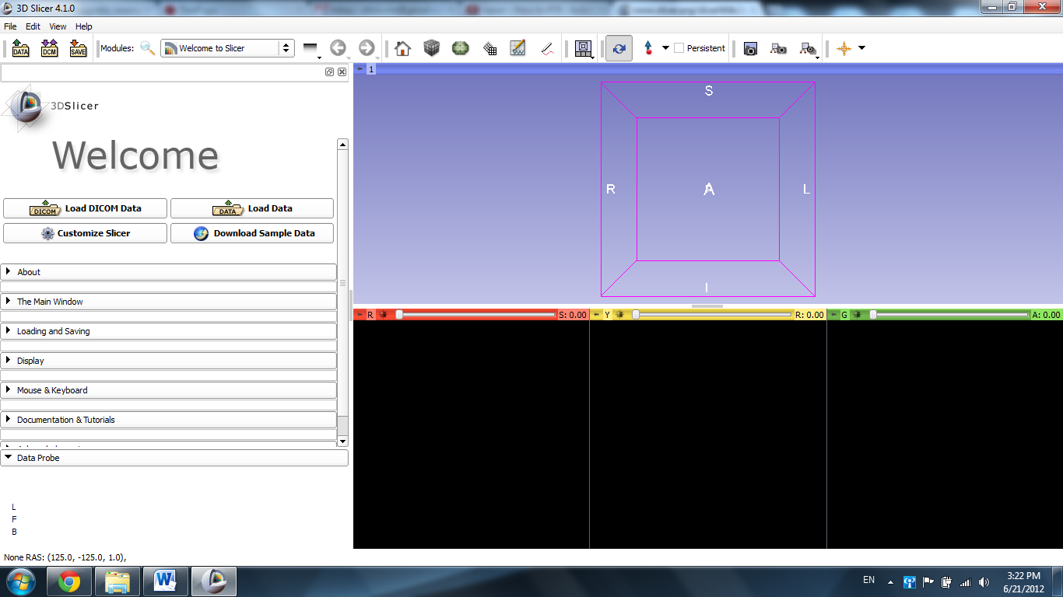
Open the File tab and choose Add Data.
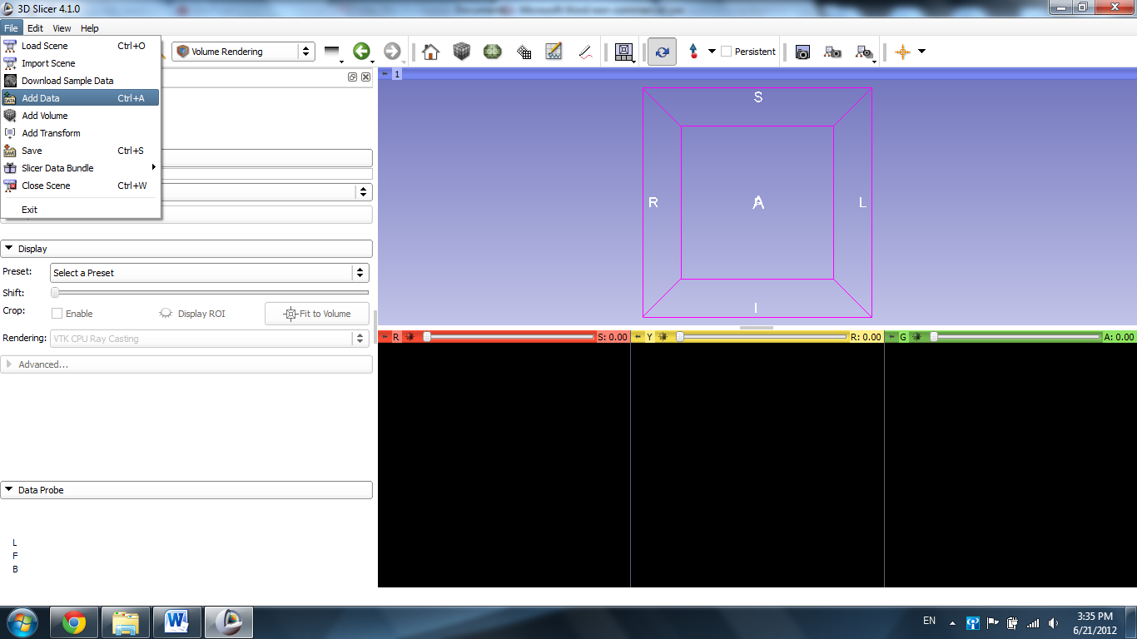
Select Choose File(s) to Add
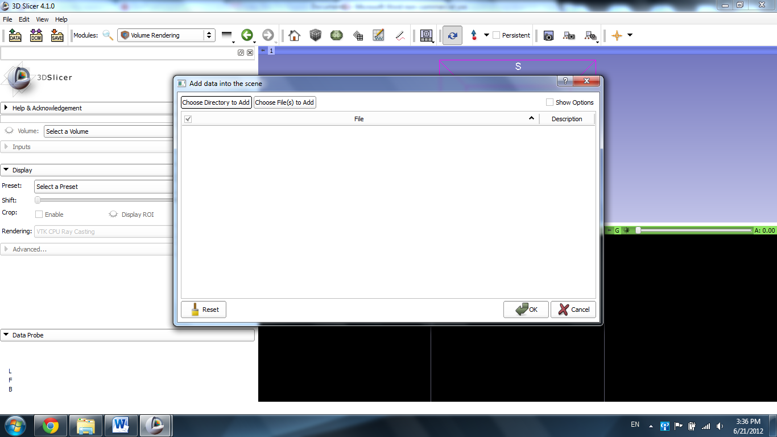

Select the file “Case 19_007_AX_3d_truefisp_for_pelvis.nrrd”
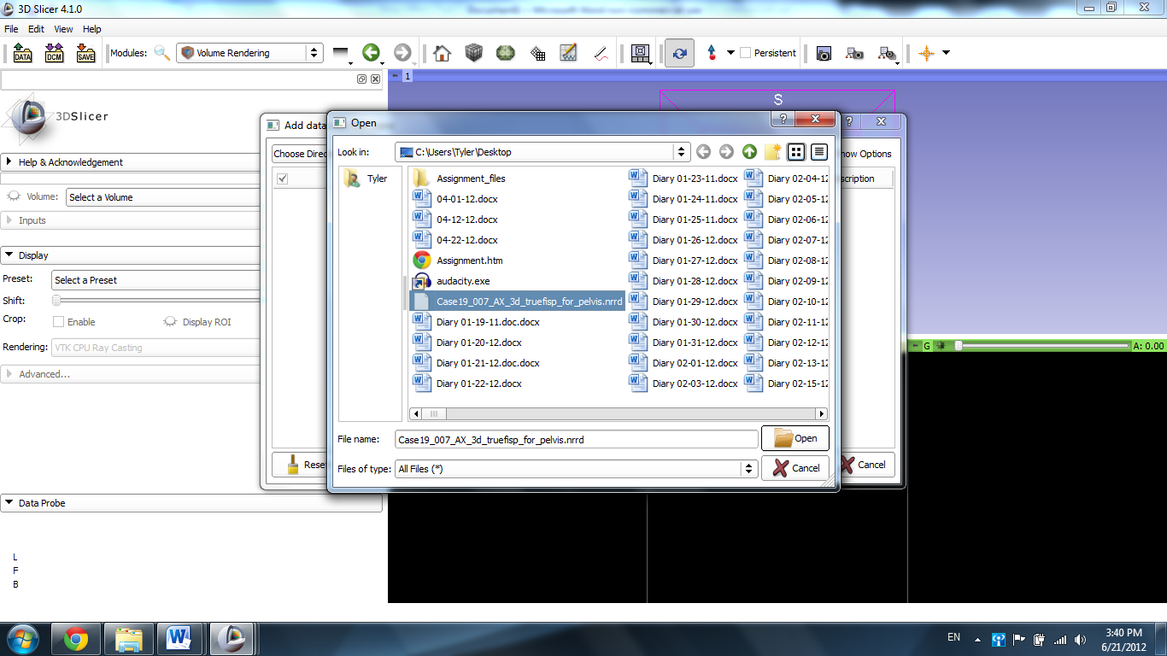

Click OK.
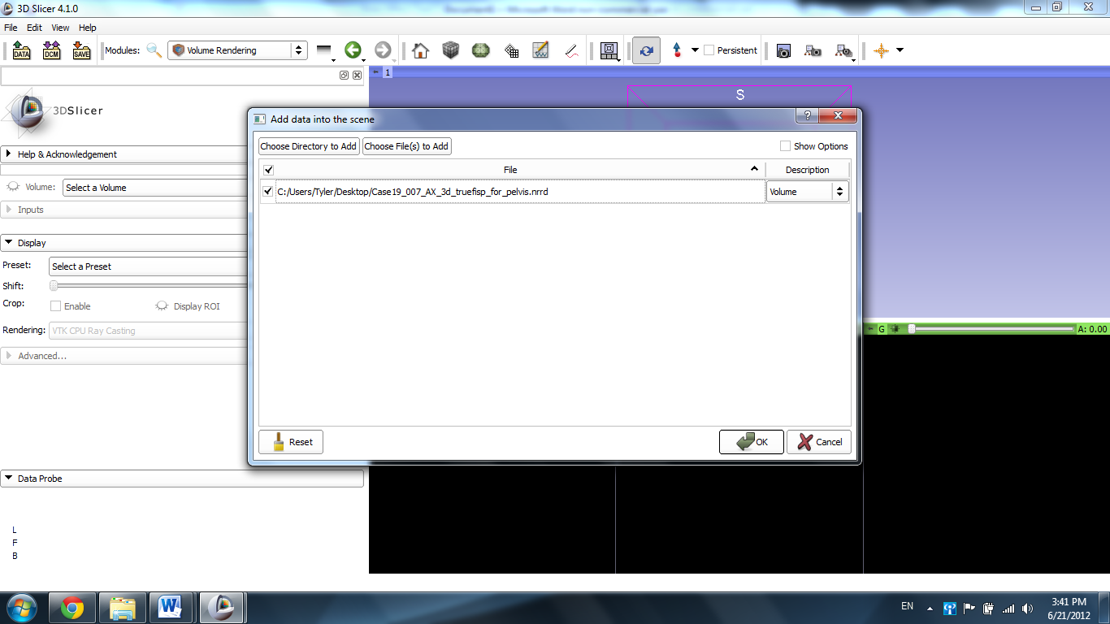

Slicer displays the pelvis slides in the windows.
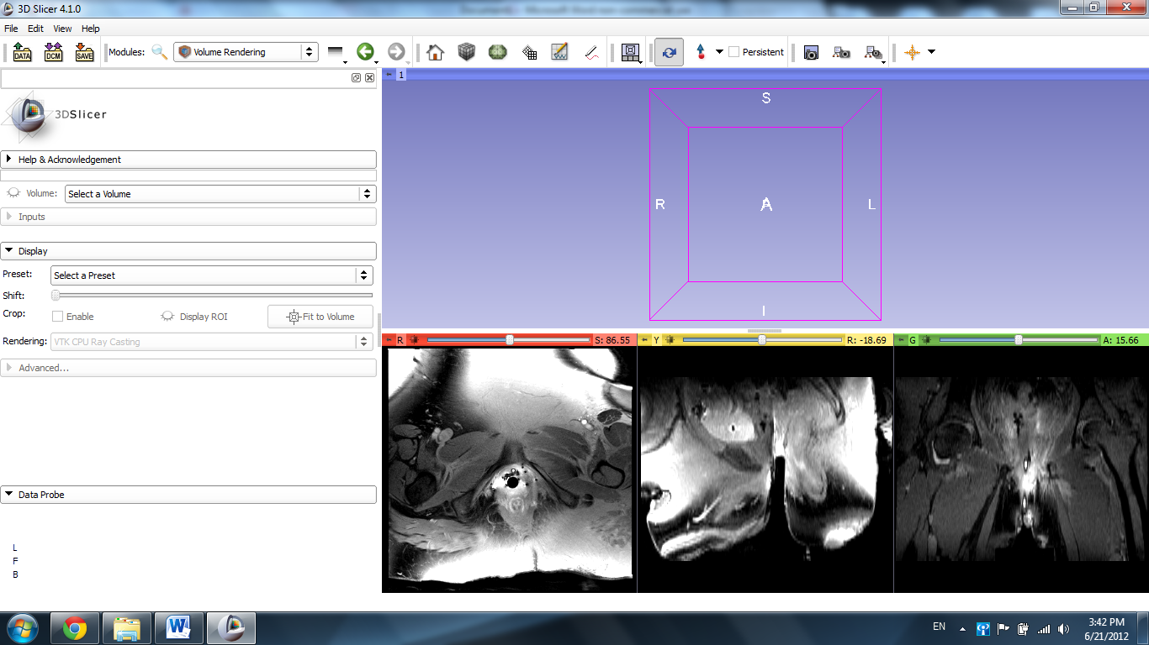

Scroll through the red slide using the mouse wheel or the track pad or the slider at the top of the slide window until the bladder is found.
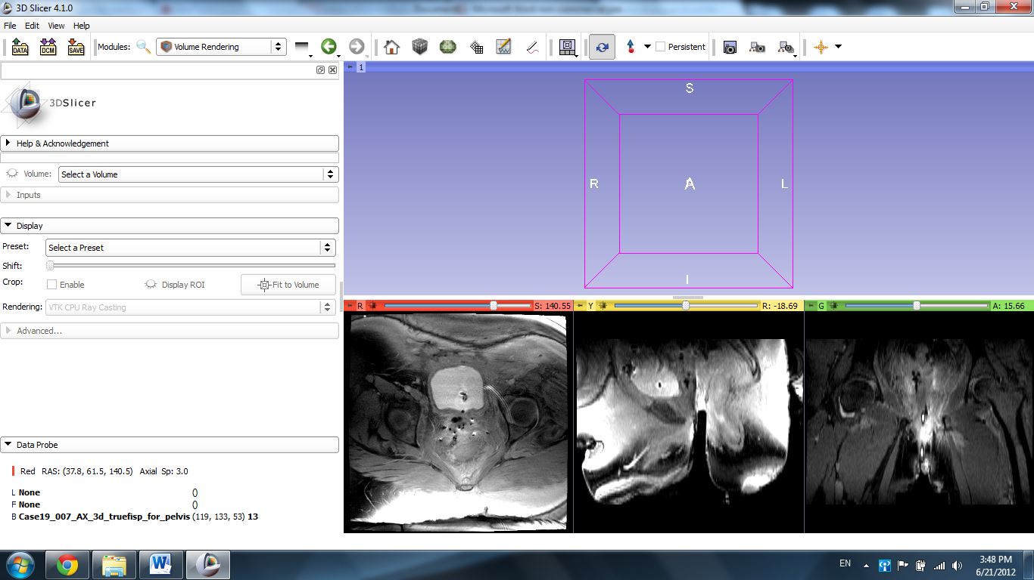
Select the Volume Rendering option in the All Modules tab in the Modules menu.
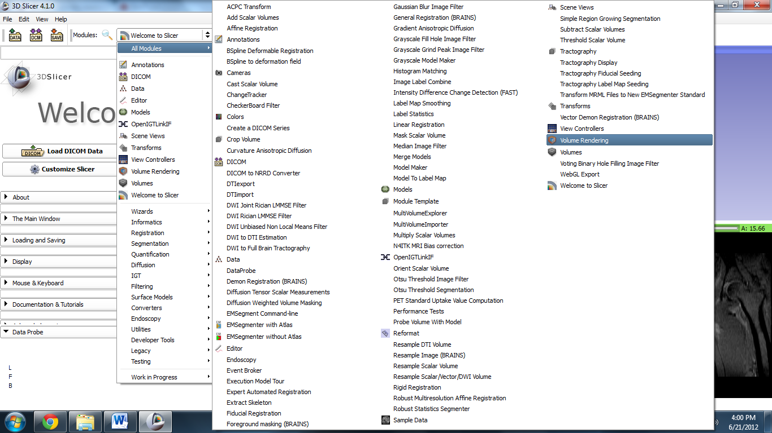
Select the Volume corresponding to the current file if it is not already, and click the eye icon next to Display ROI.
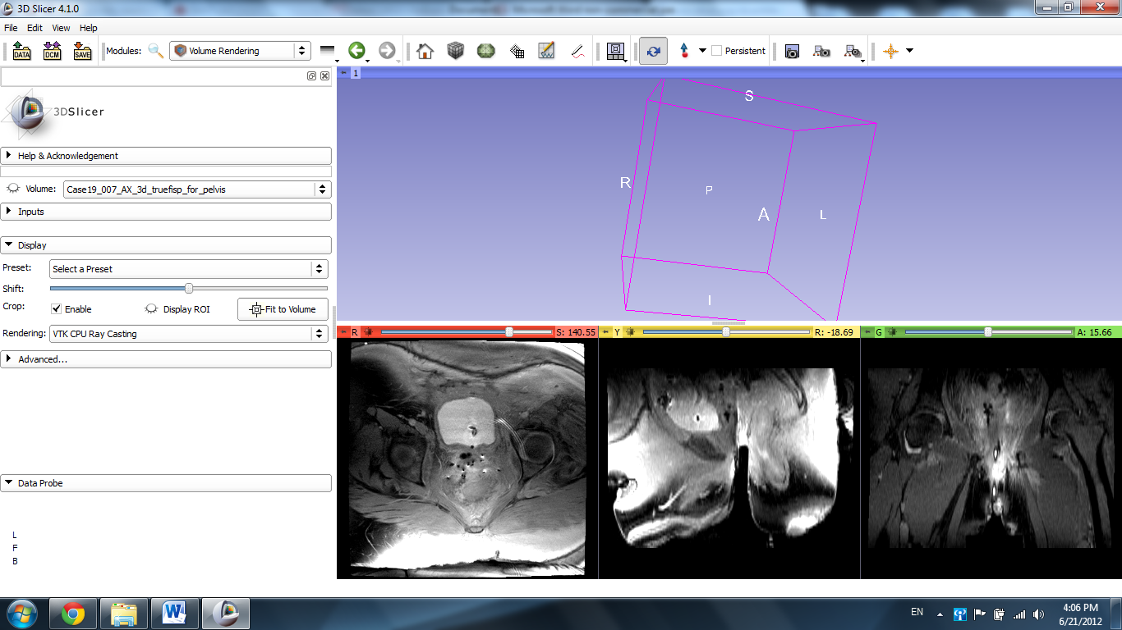

Slicer displays the cropping box in the 3D window and each slide.
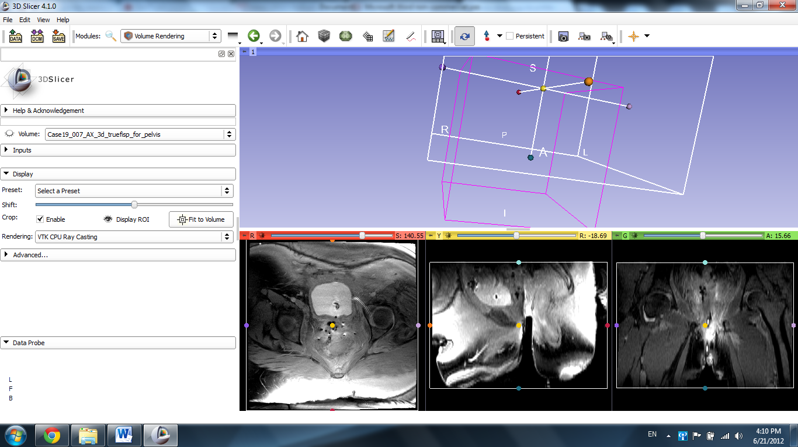
Drag the crop box boundaries to surround the organ in question (the bladder), leaving some space for editing.
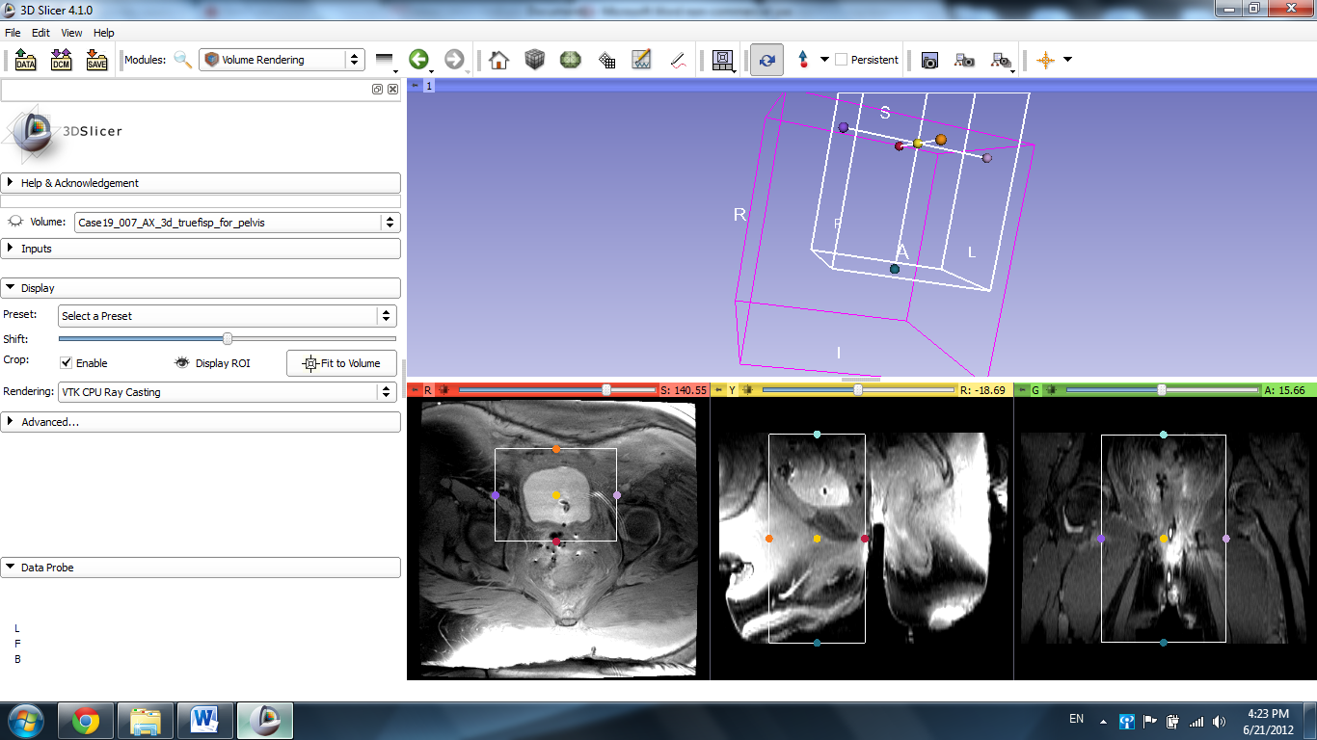

Click the Red Slice Only view for editing purposes.
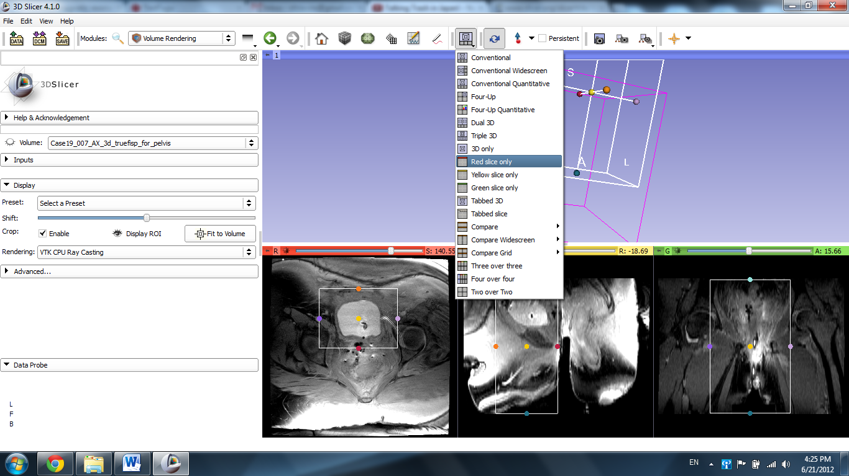
Slicer displays the Re Axial Slice in the main window.
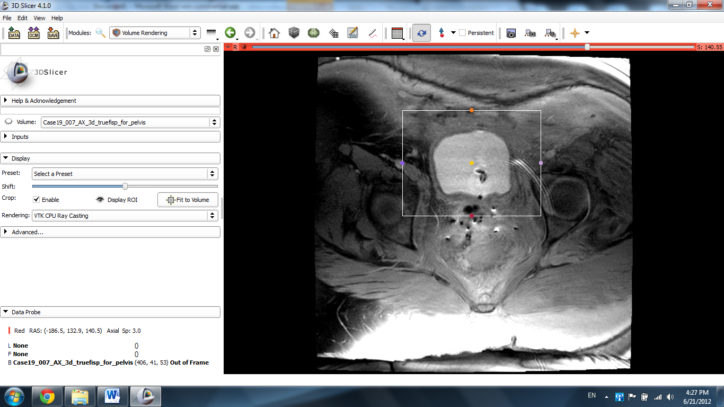

Select the Crop Volume module.
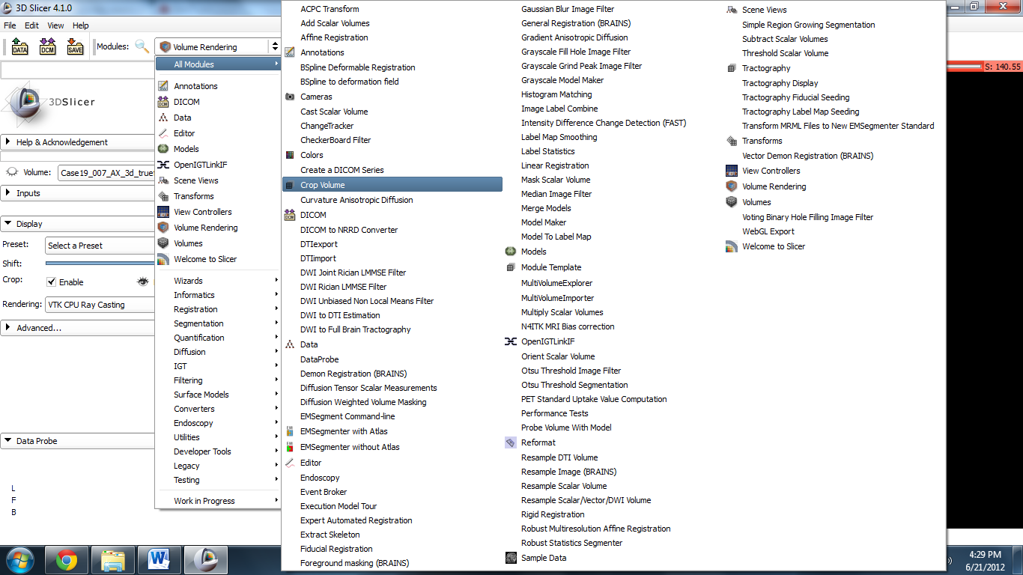

Select the Crop button to reduce the image.
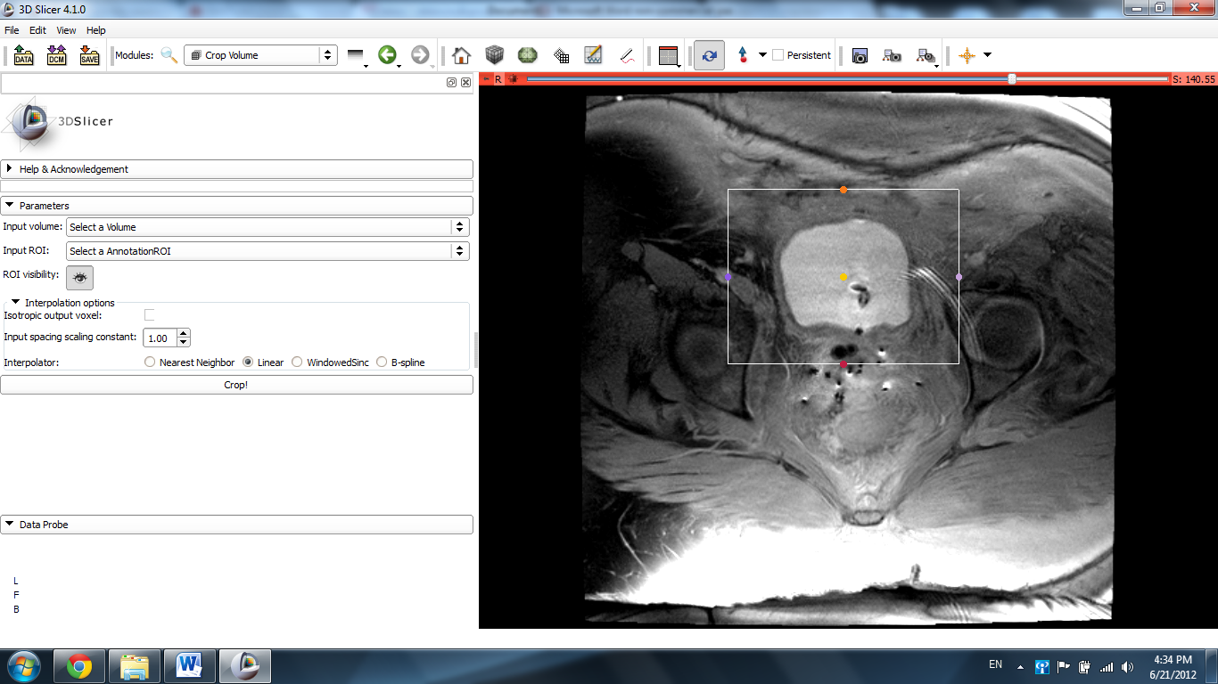

Slicer displays the result of the cropping.
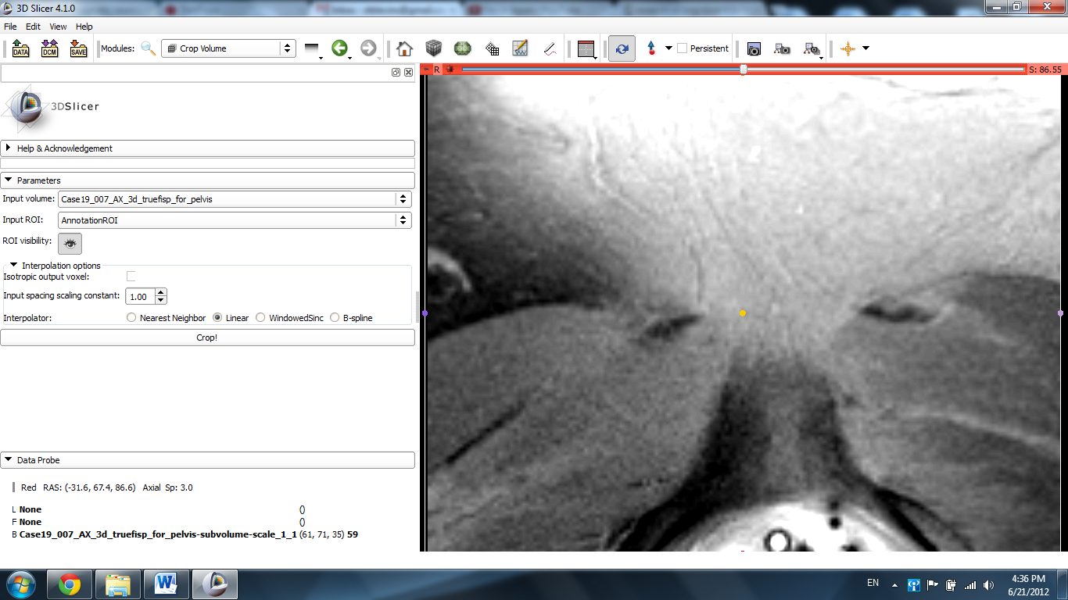

Scroll through the slides using the mouse wheel or the track pad or the slider at the top of the slide.
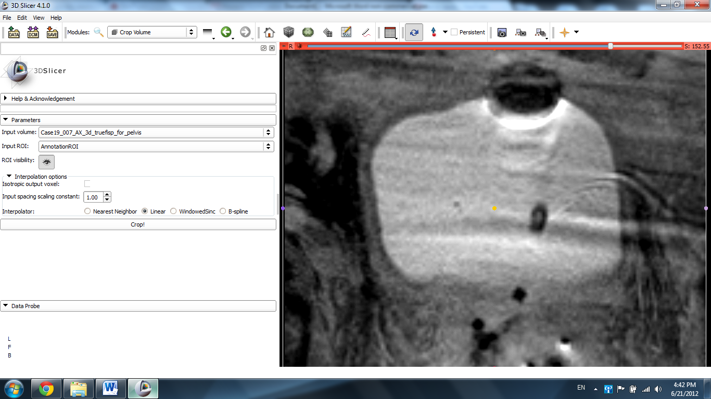

Select the Editor module from the menu.
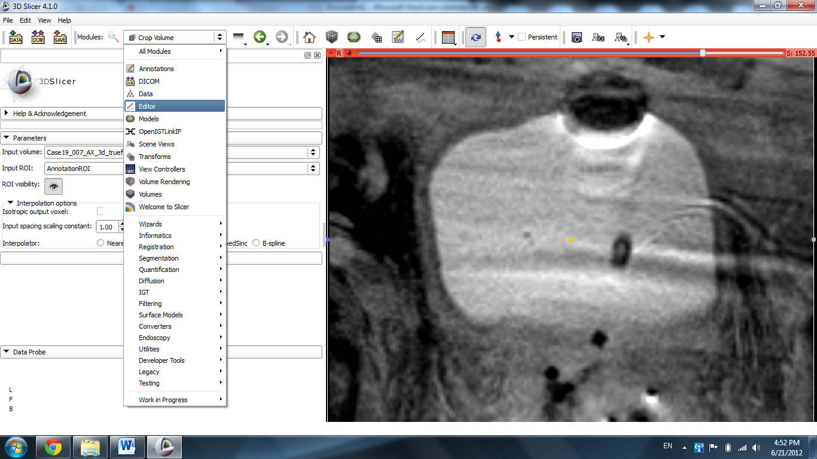

Click Apply.
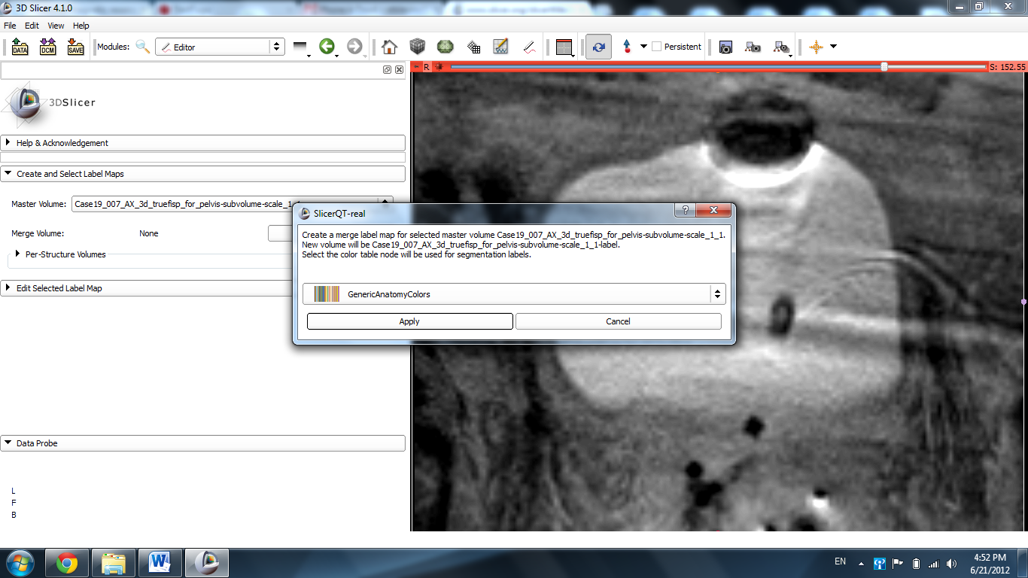

Select the Paint tool from the icon selection.
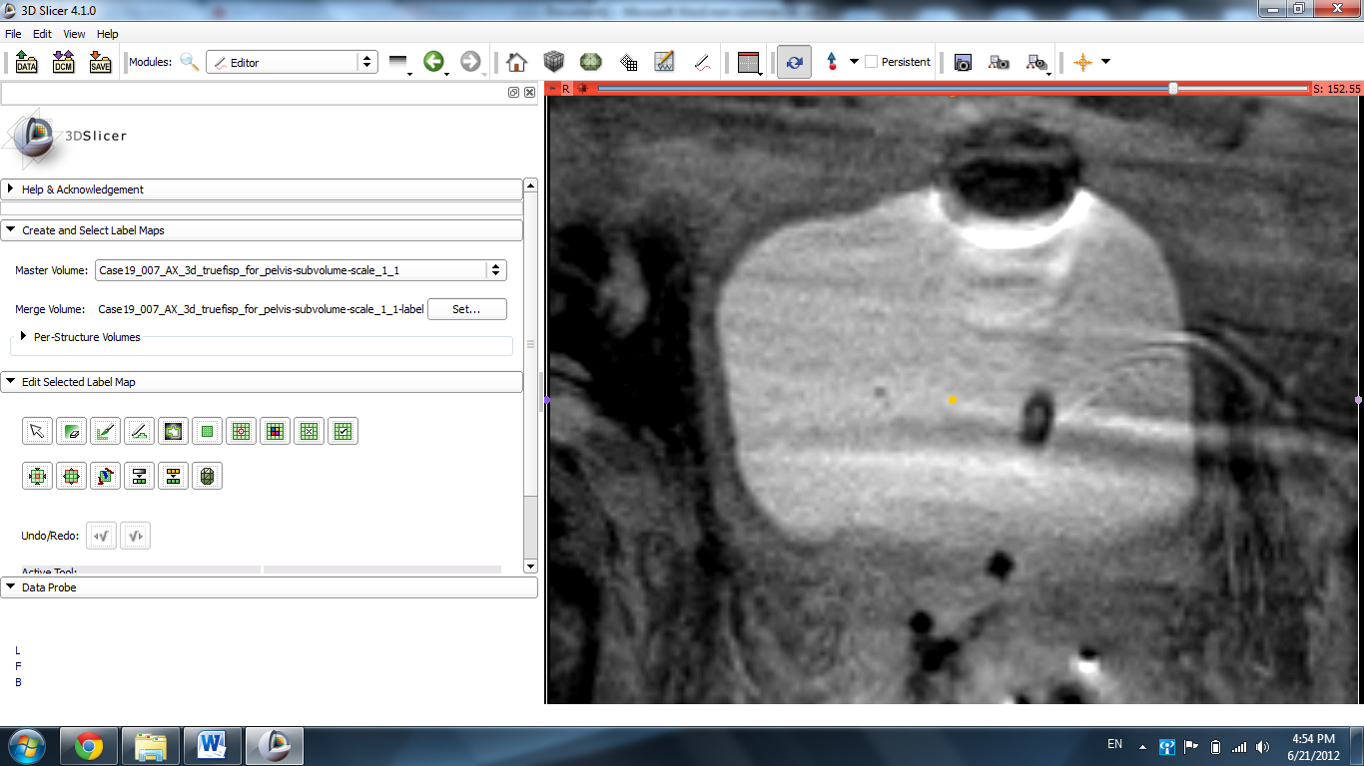

Make a mark on the organ in question.
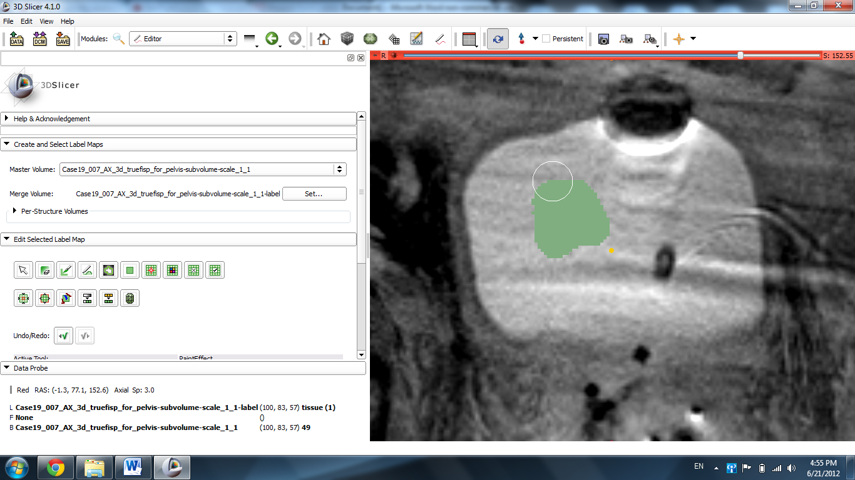

Draw a circle around the organ with a different label color.
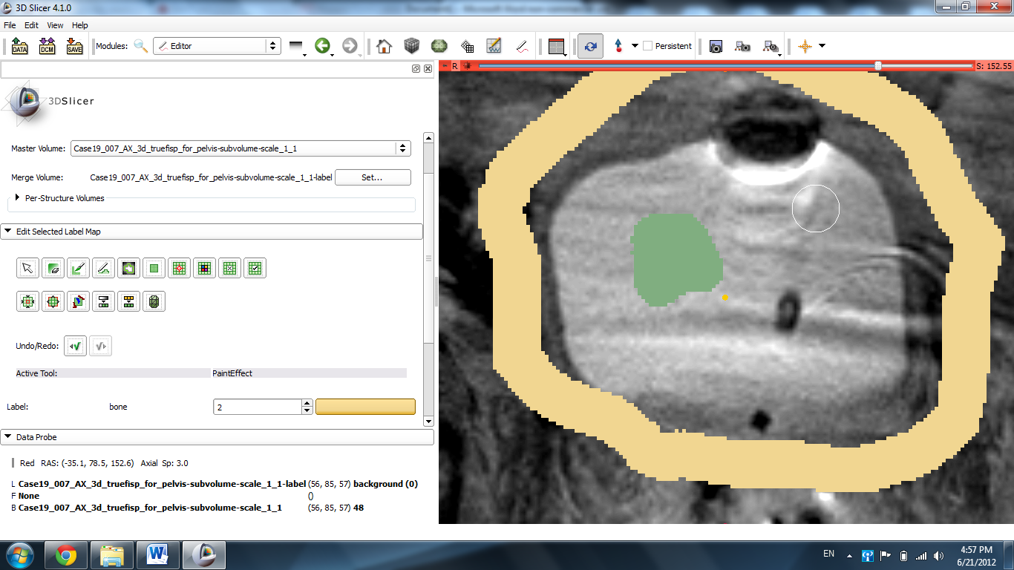

Select the Grow Cut effect and click Apply.
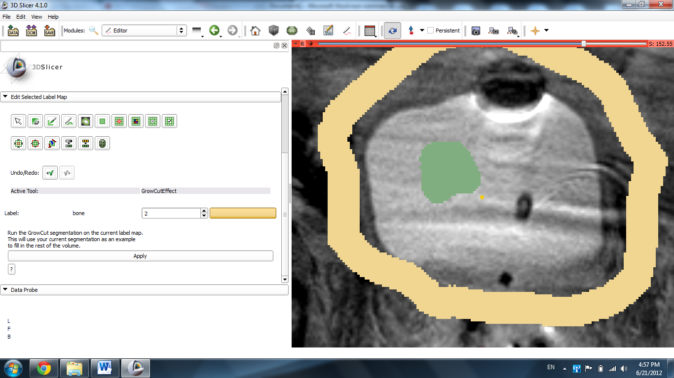

Slicer displays the results of the segmentation.
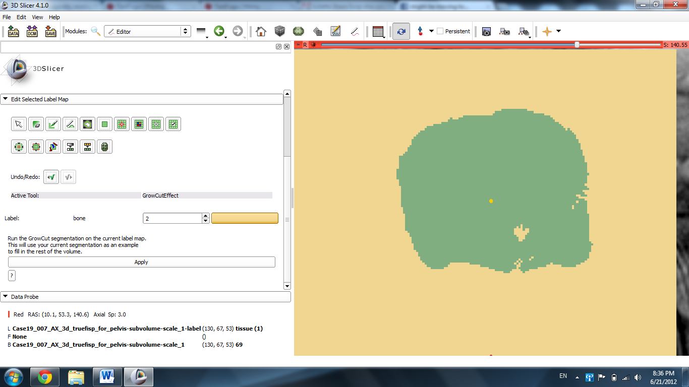

Use the Draw tool to fill in any blank spots or remove any extraneous spots using the 0 label.
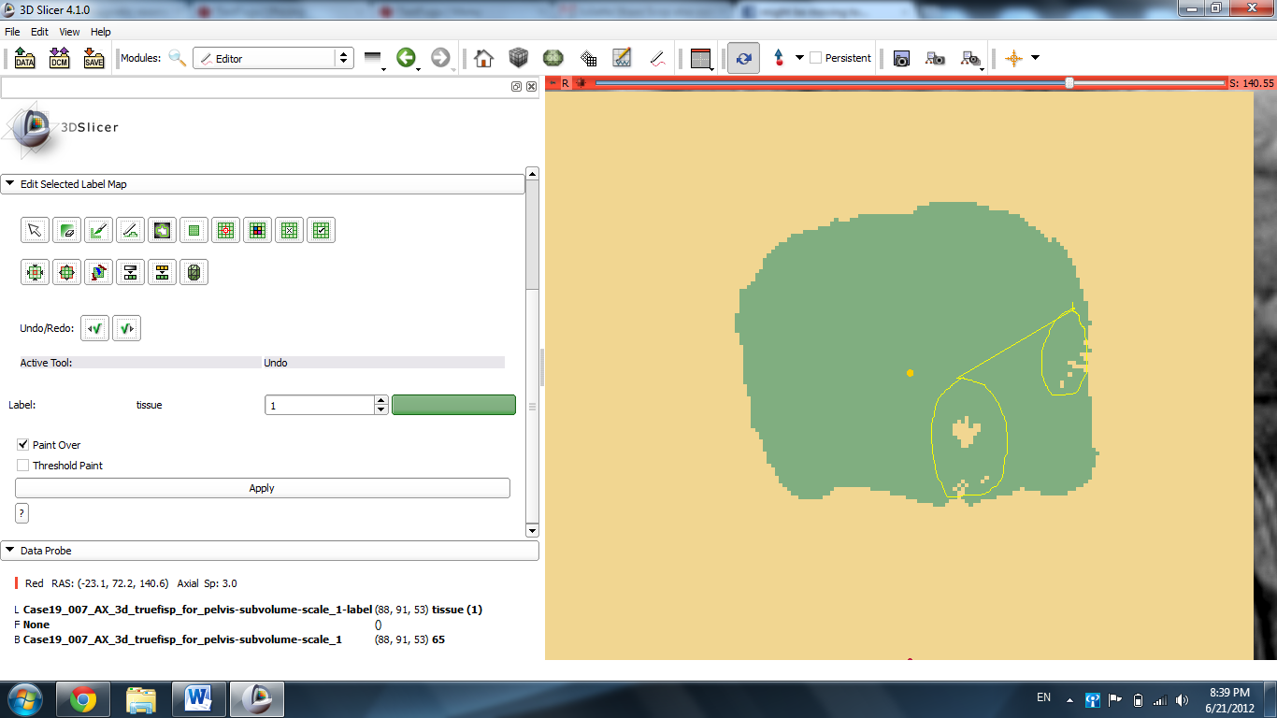

Press Enter to fill in the blank spots.
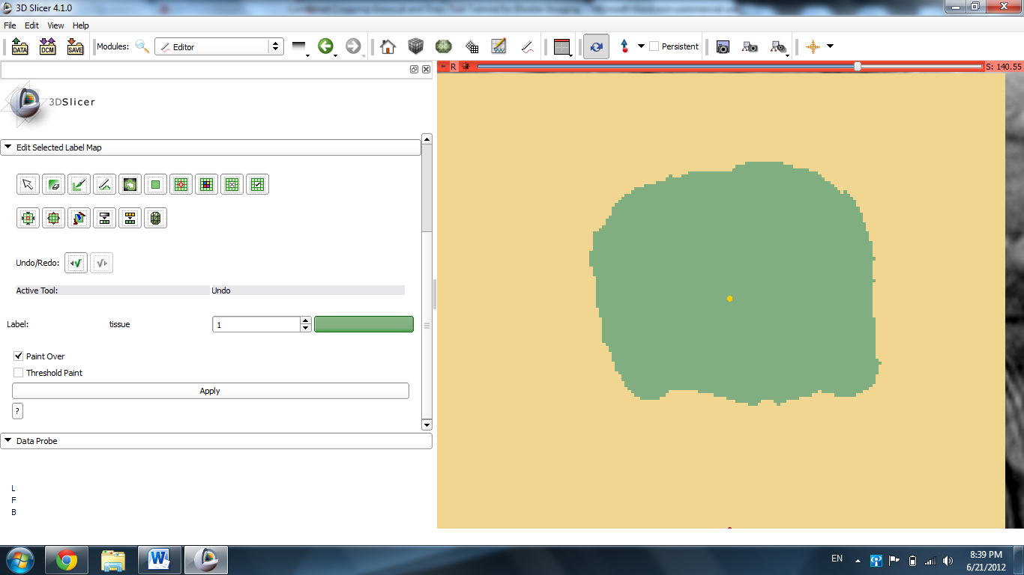

Use the Change Label Effect to remove the peach background. Set the input and output volumes to 2 and the background to 0 and click Apply. Slicer removes the background slice.
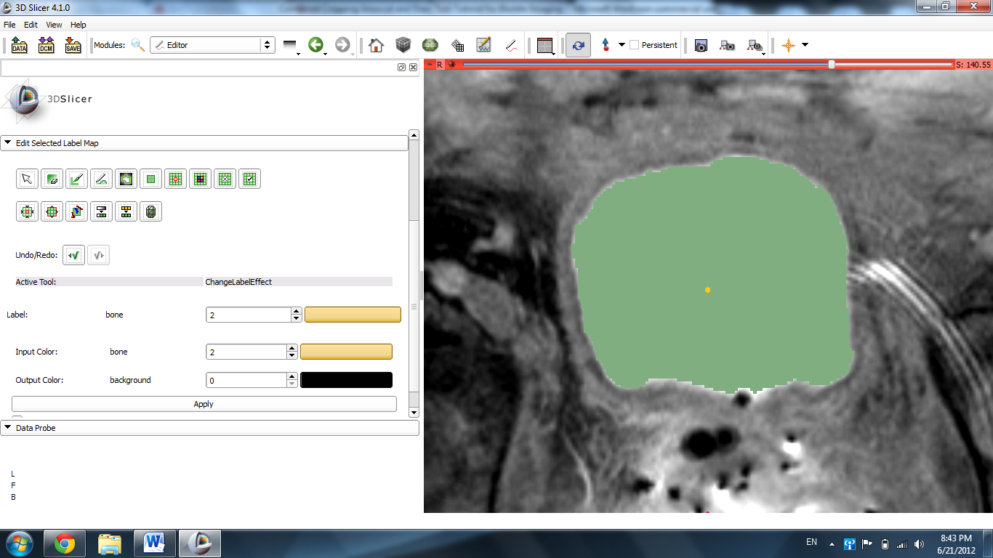

Click the left upper pin in the red slice and the double arrows that follow. Click the link icon to extrapolate this to the other images. Hover the mouse over the window with a 1.00 in it and drag the bar down so it reads ~0.50. Slicer fades the label to reveal the bladder.
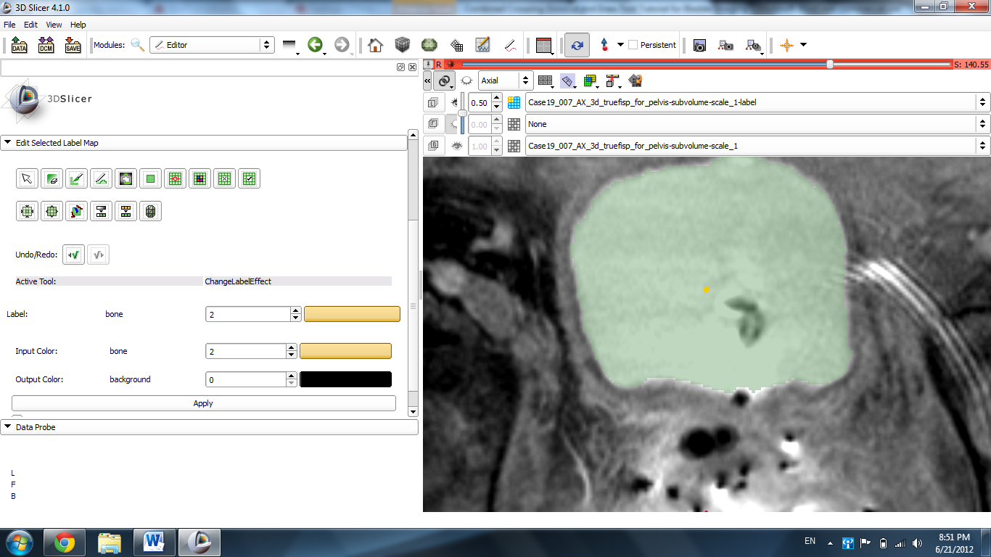

Click the Per-Structure Volumes tab, then Split Merge Volume
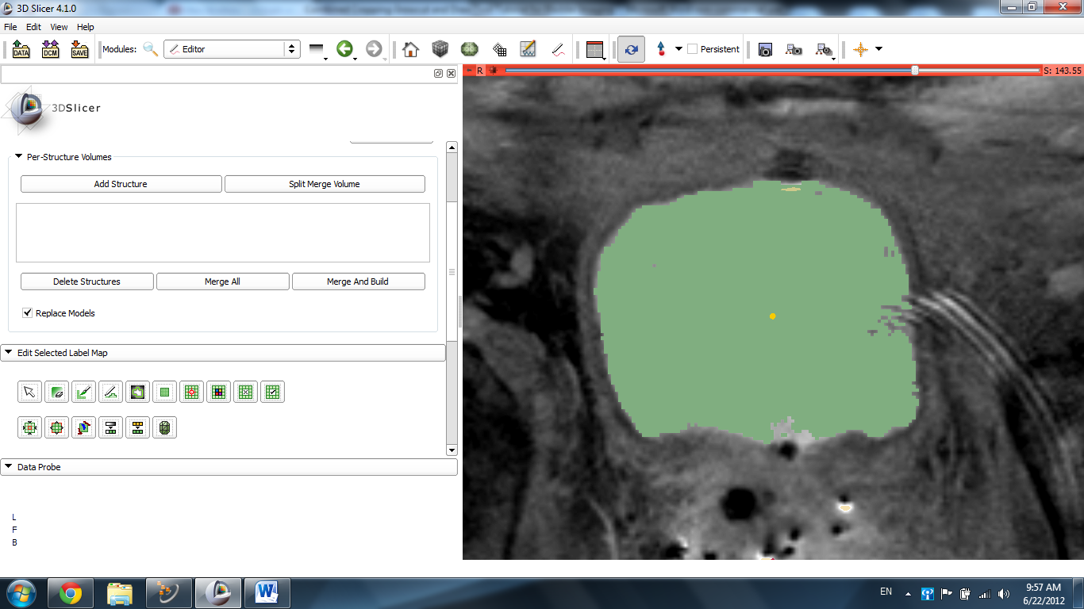

Click the label in use, then split merge volume to generate the 3D image.
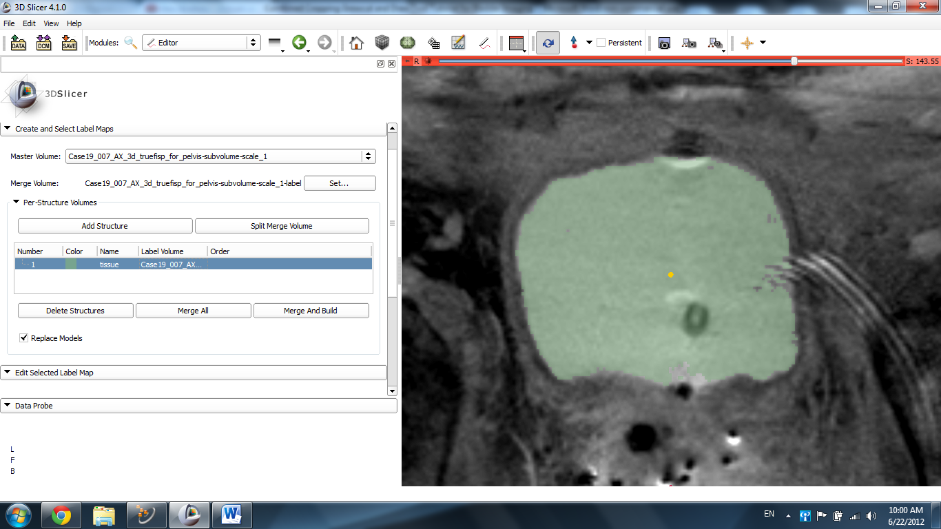

Select Conventional View from the menu.
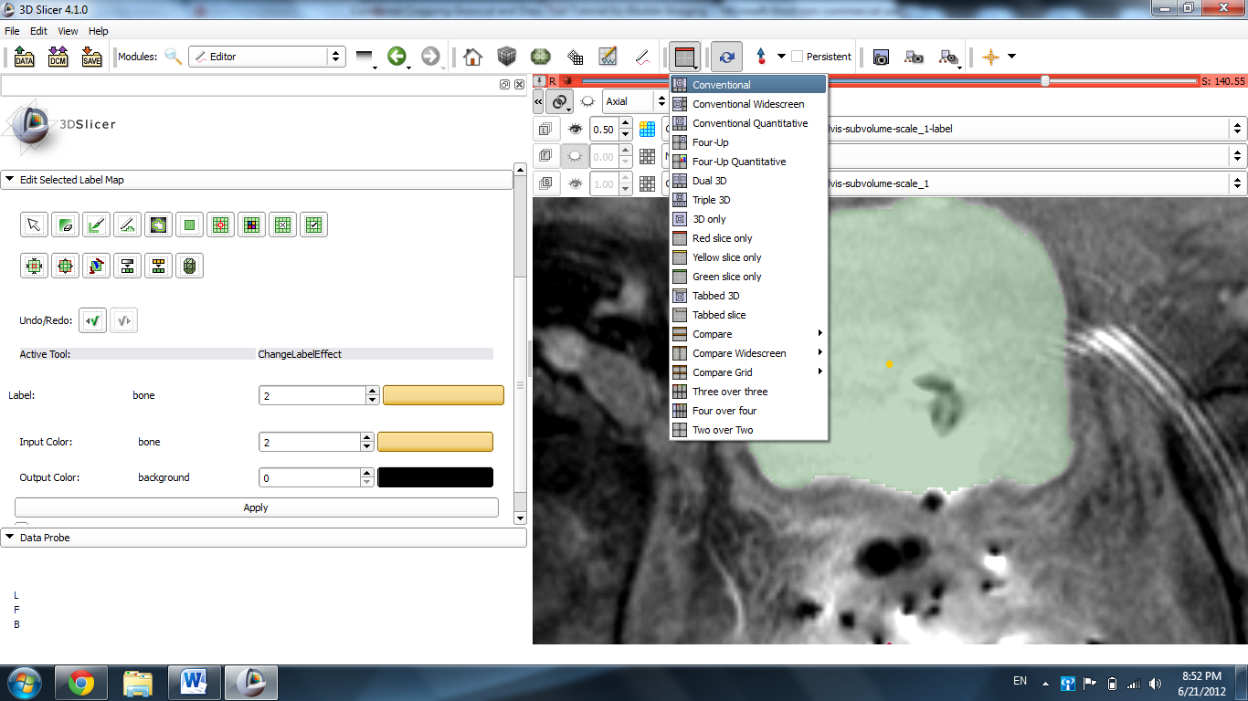

Slicer displays the results of the 3D image.
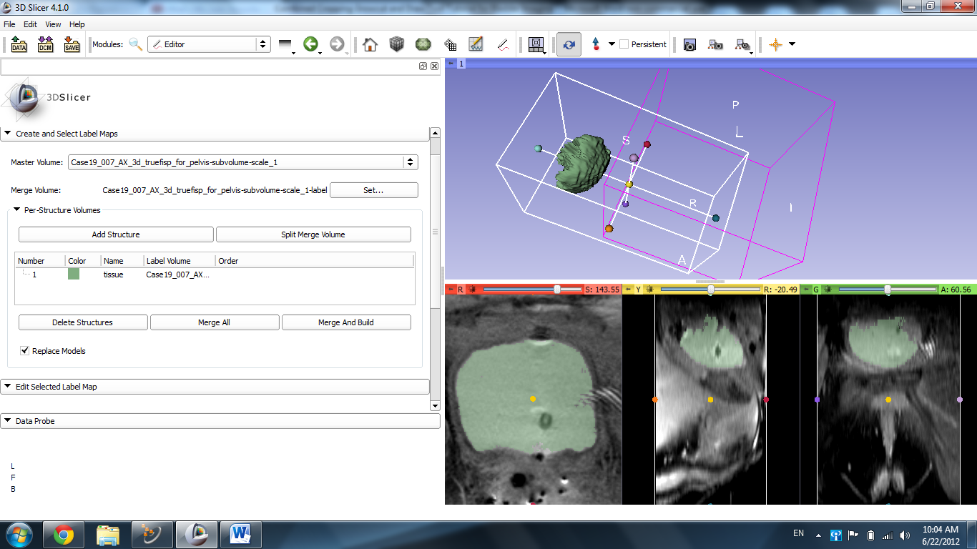

Click the 3D center image icon in the pin in the top left of the blue screen to center the image.
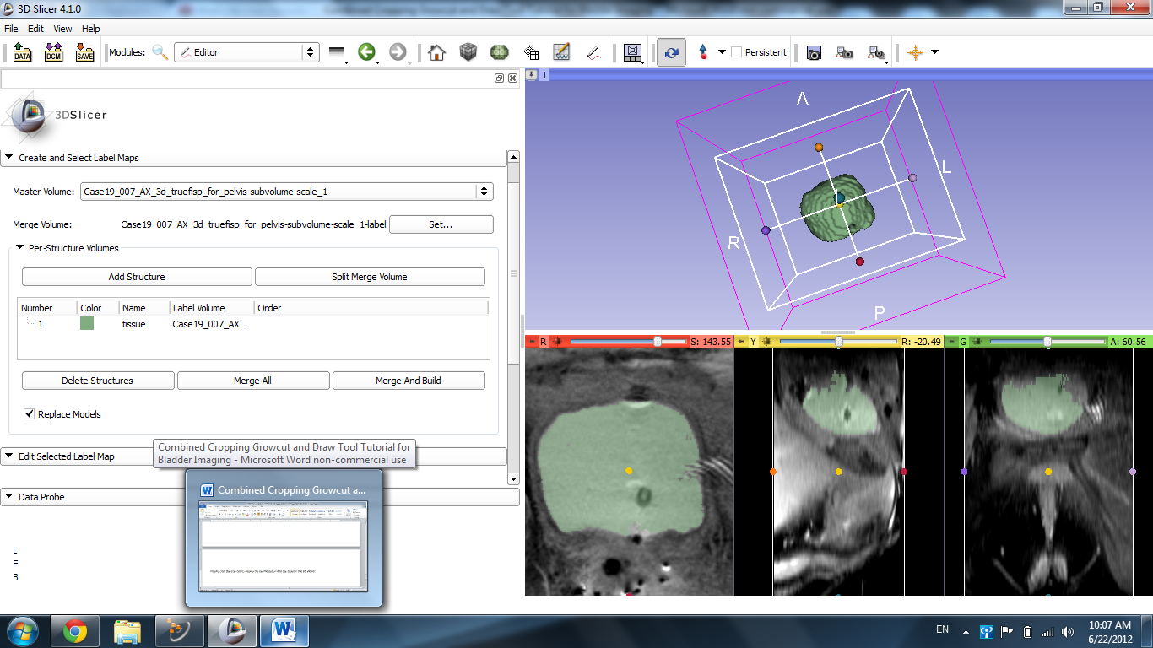

Finally, click the eye icon to display the segmentation and the slides in the 3D viewer.
