Draw Effect Tool Tutorial for Bladder Segmentation
By Tyler Blevins

Open Slicer. The Slicer main page welcomes you.
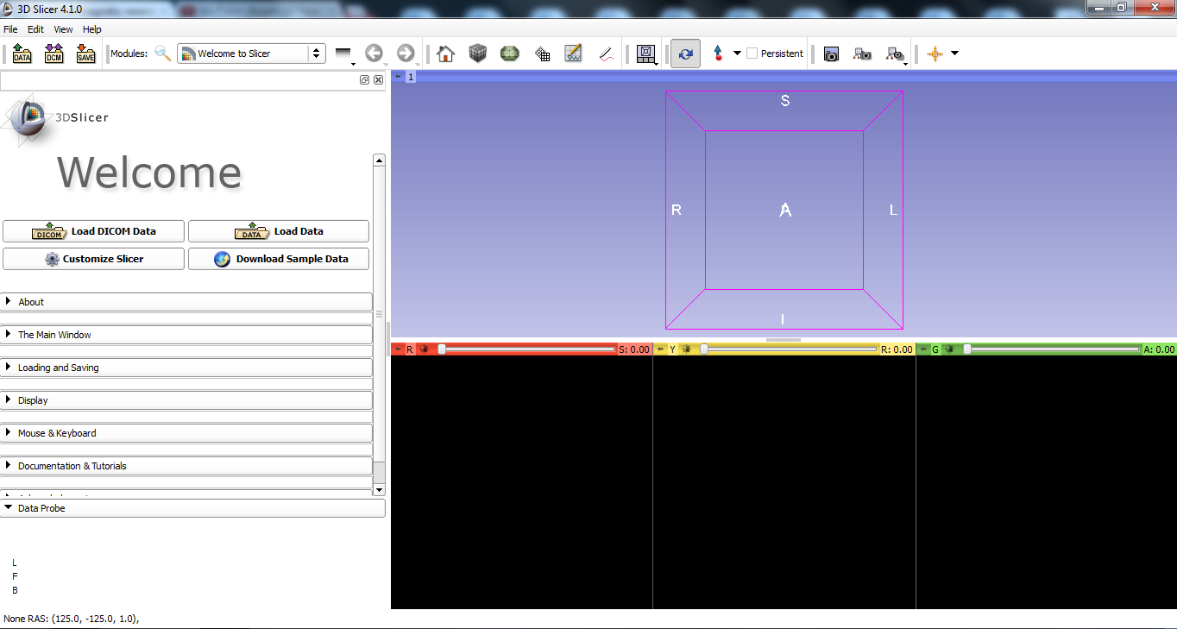

Open the File menu and select Add Data
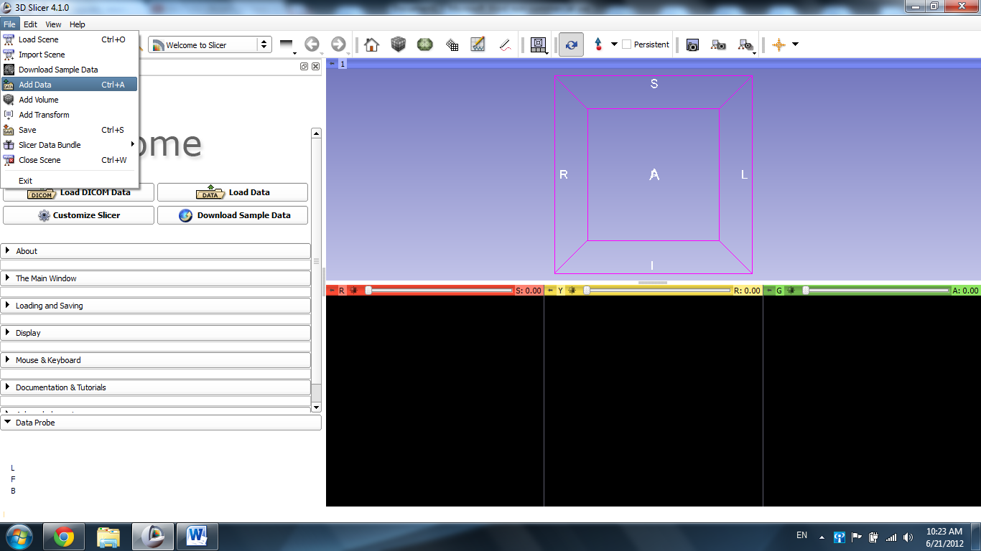
Select “Choose File(s) to Add.”
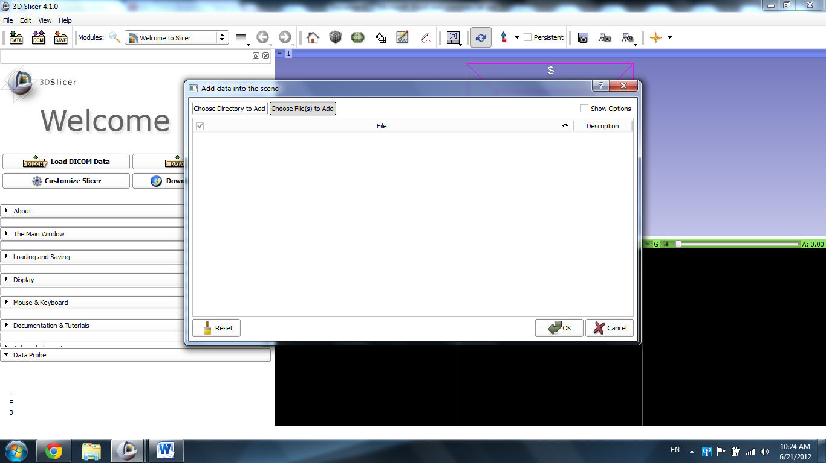

Select the file “Case 19_007_AX_3d_truefisp_for_pelvis.nrrd”
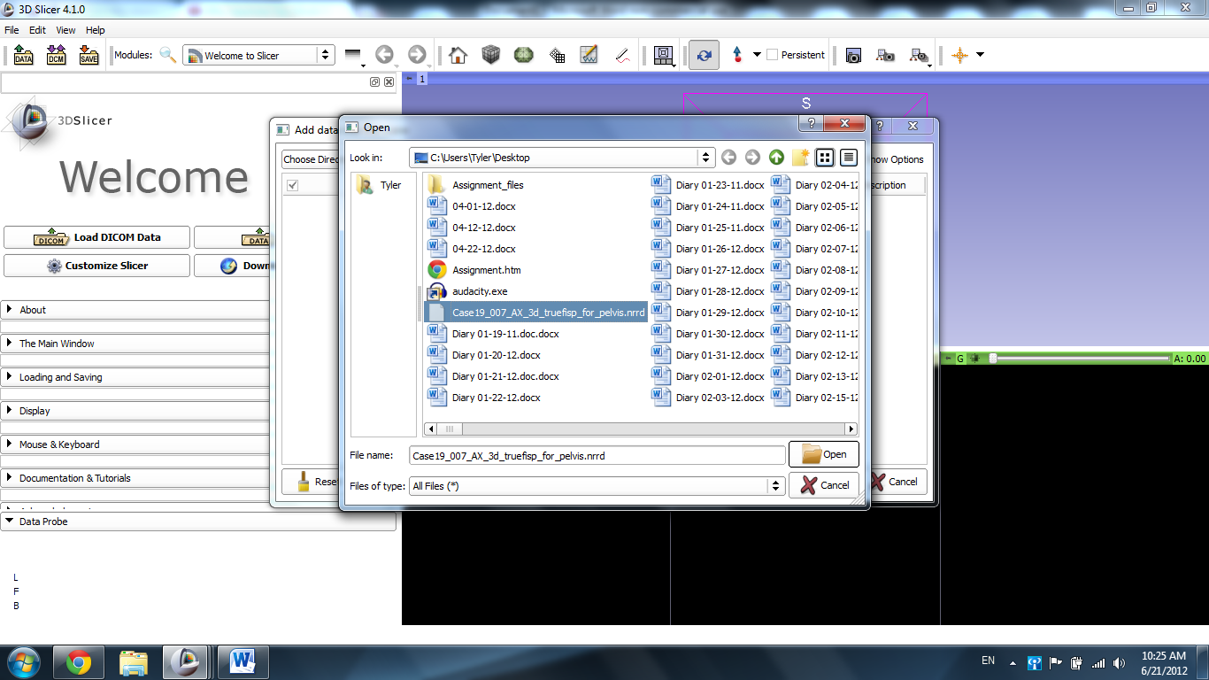

Click “OK” to load the scene.
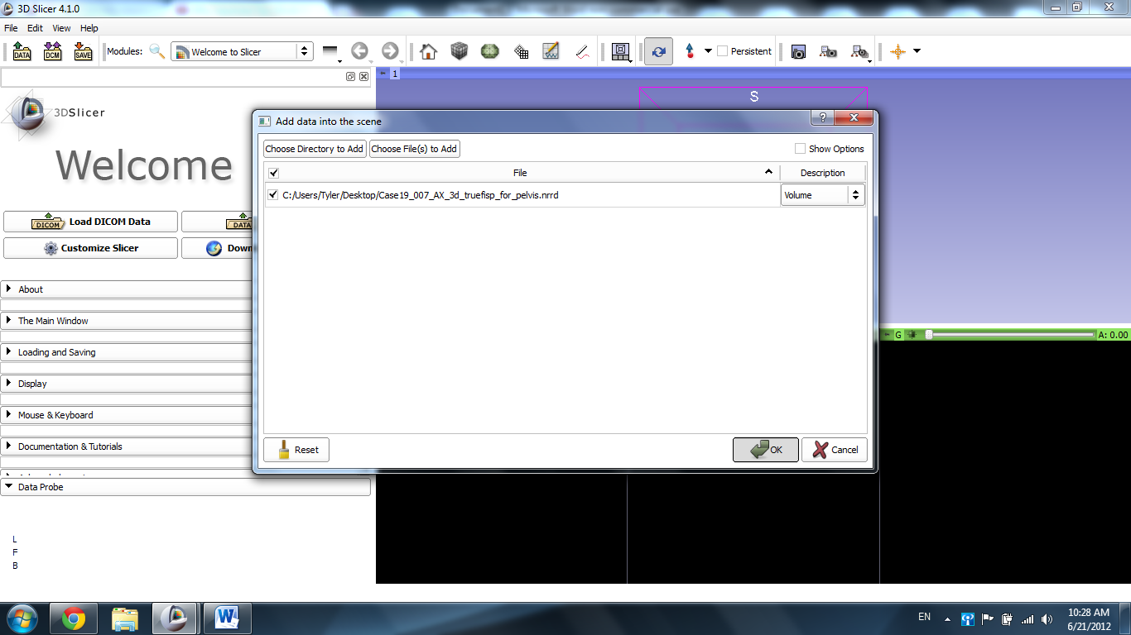

The scene loads MRI images of the pelvis.
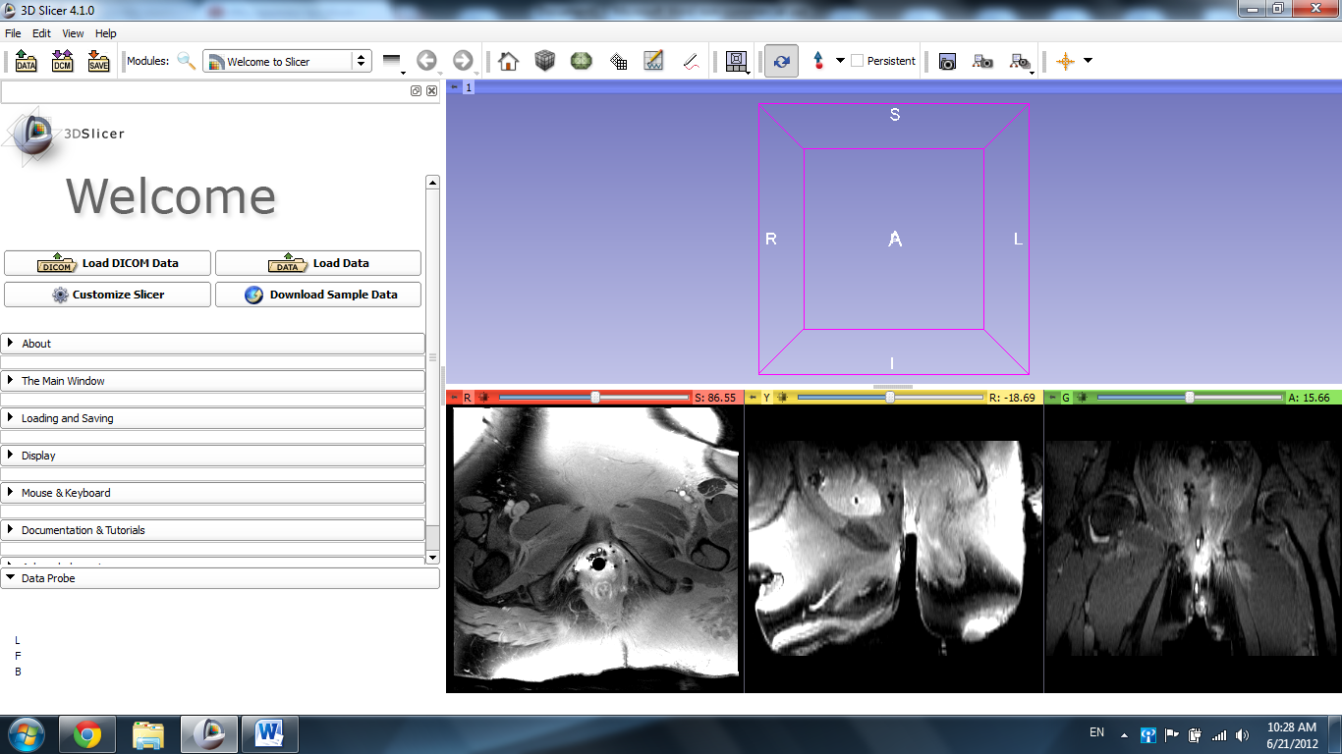

Select the “Red Slice Only” tab in the viewer tab.
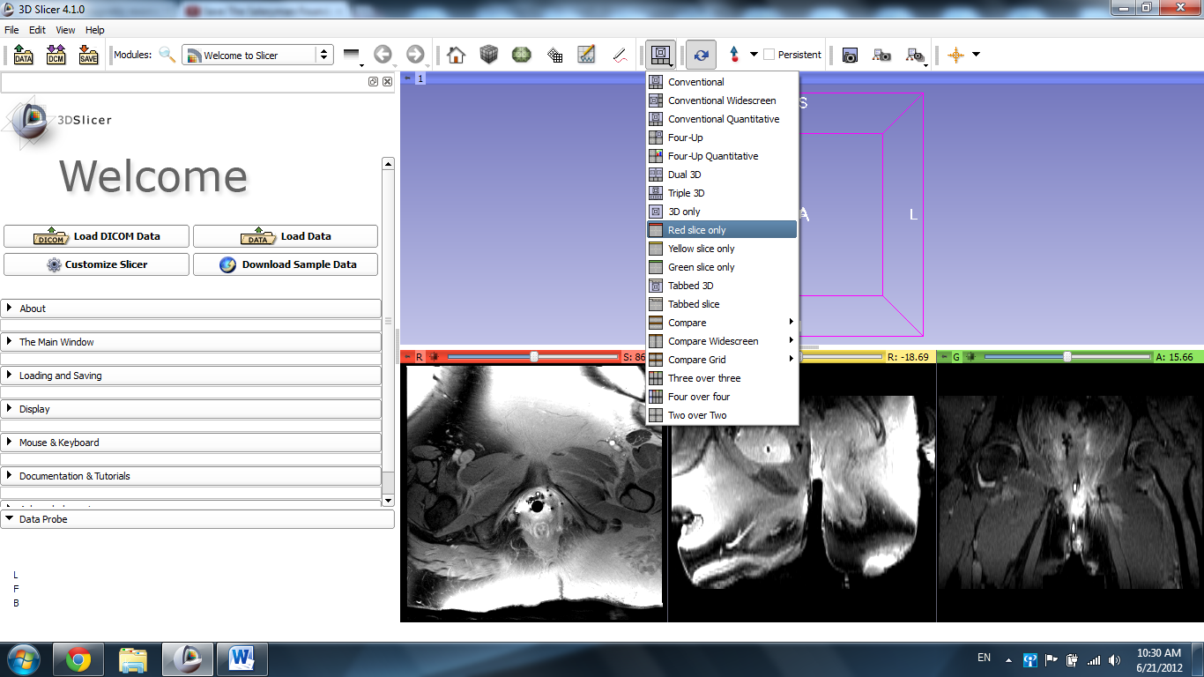

The Red Axial Slice appears in the large main view.
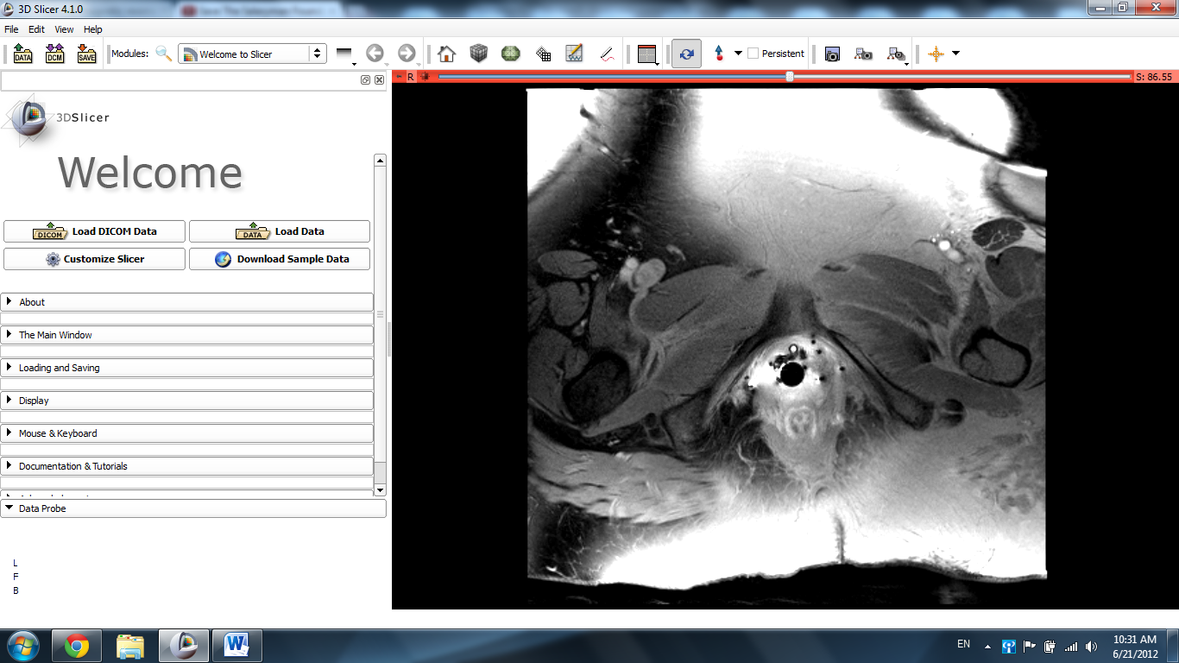

Use the scroll tool on your mouse/trackpad or the slider on top of the image window to slide through the image until the bladder appears in the scan.
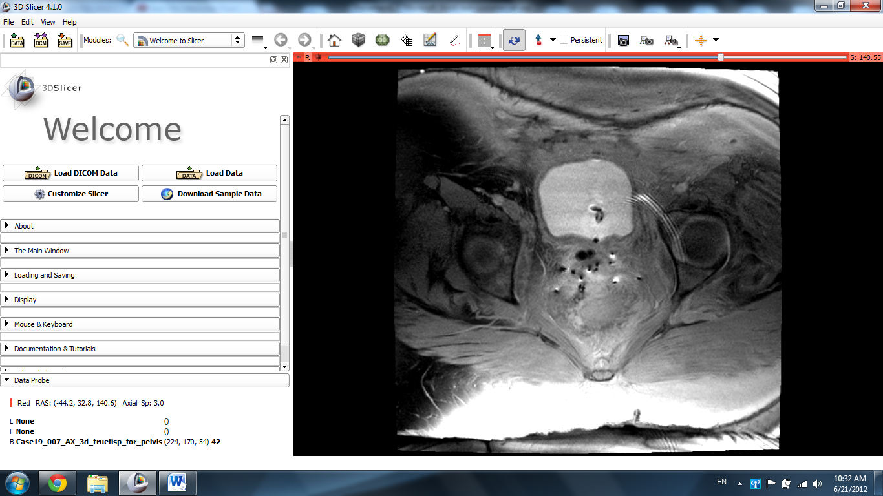

Open the Modules dropdown window and select the Editor module.
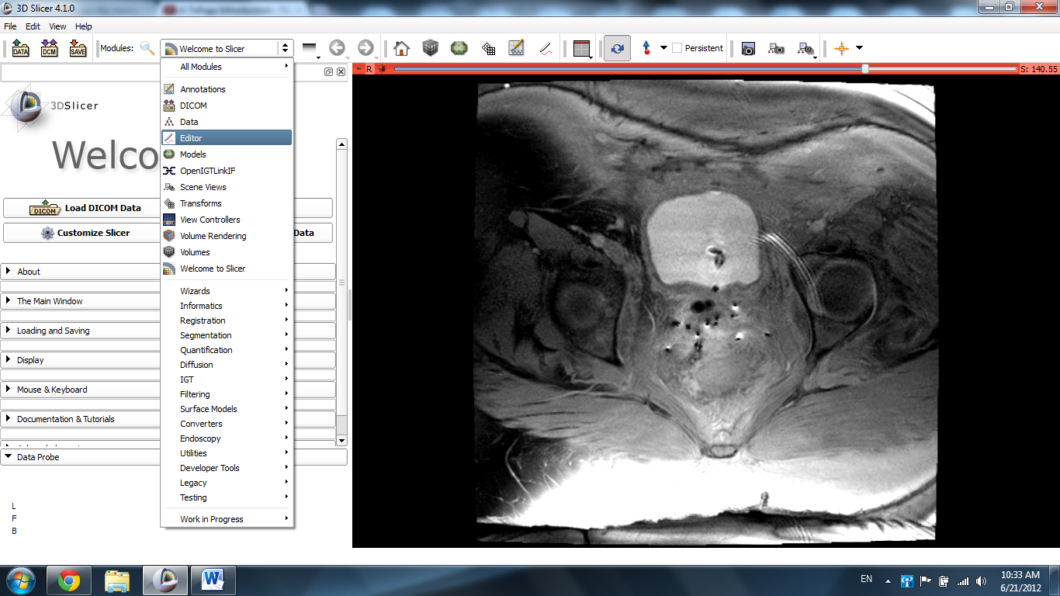
The window for label selection pops up. Leave the default GenericAnatomyColors option and click Apply.
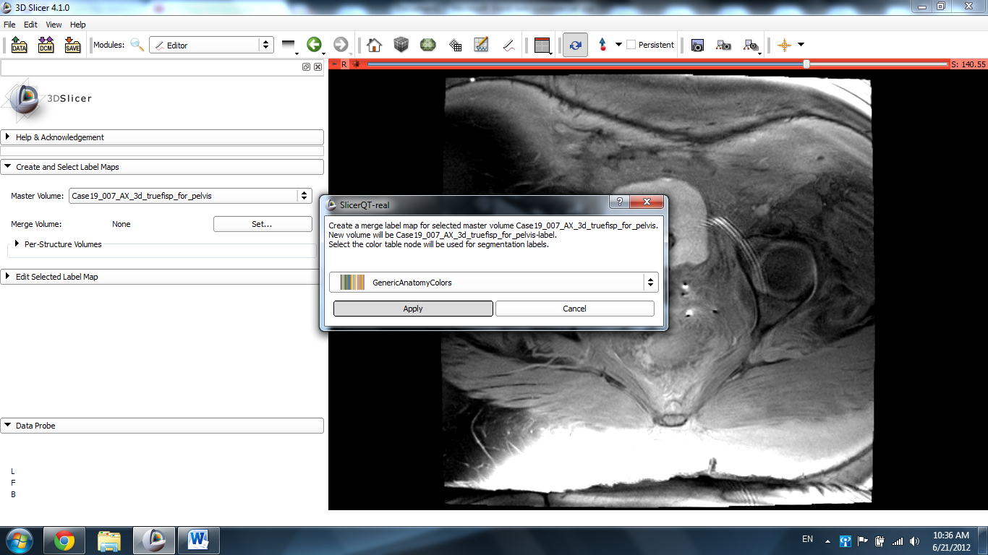

The Editor module appears in the sidebar.
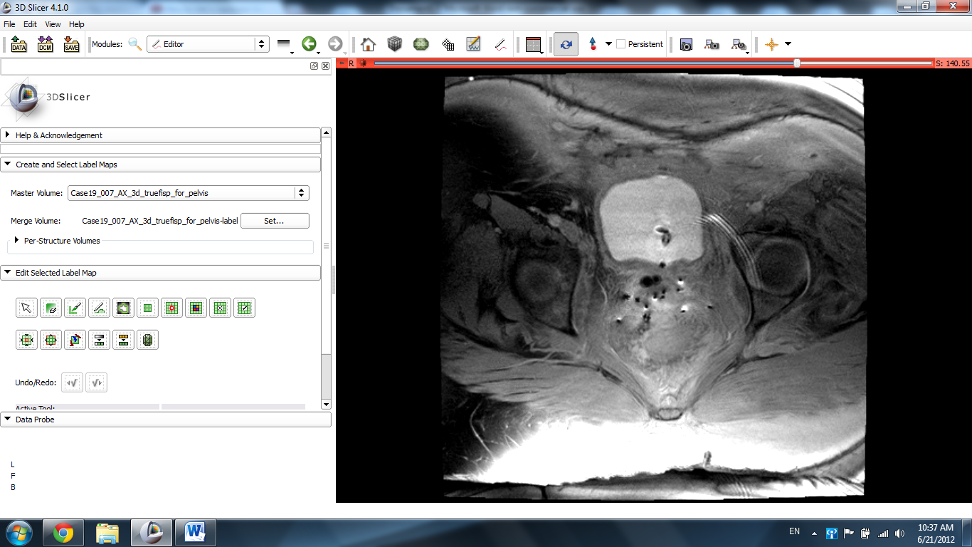
Select the Draw Effect tool from the “Edit Selected Label Map” tab.
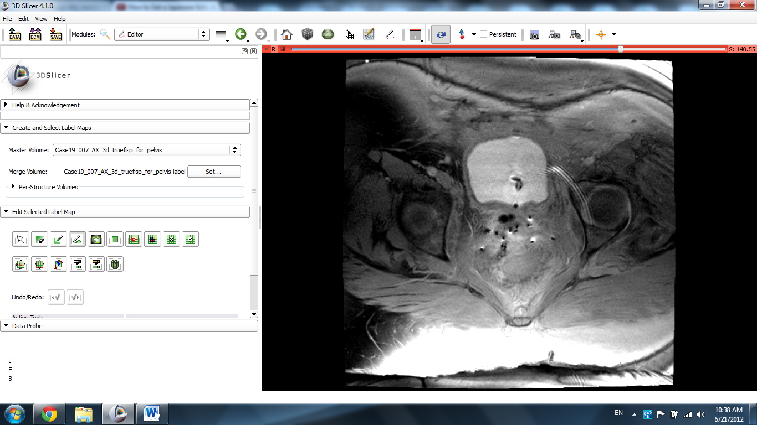
Use the Draw Effect tool to trace a close outline of the structure of interest (in this case, the bladder) with your mouse.
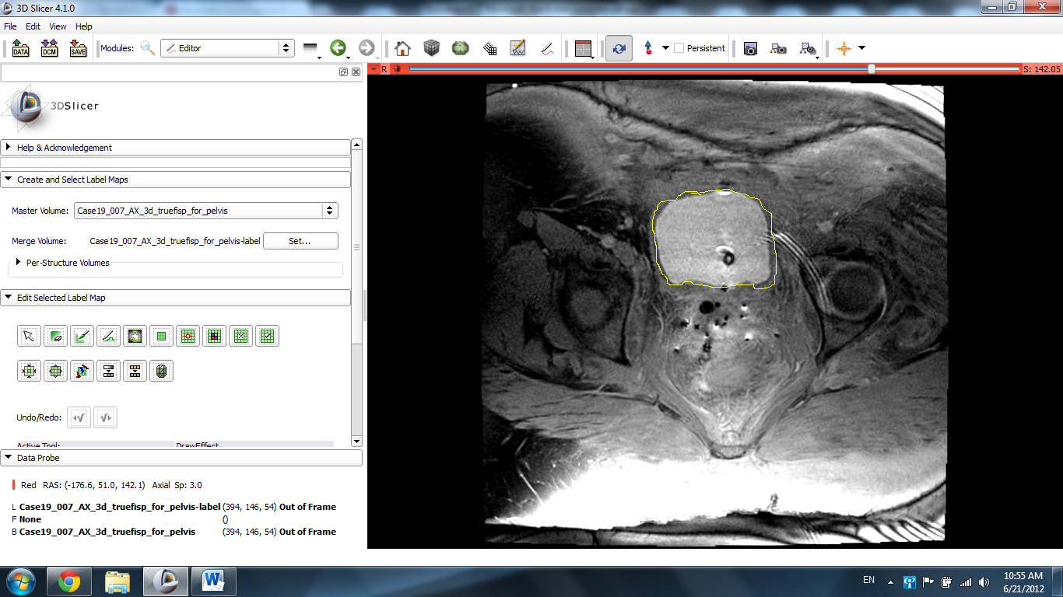

Use the Enter/Return key on your keboard to fill in the image you traced. The image fills in with a green label.
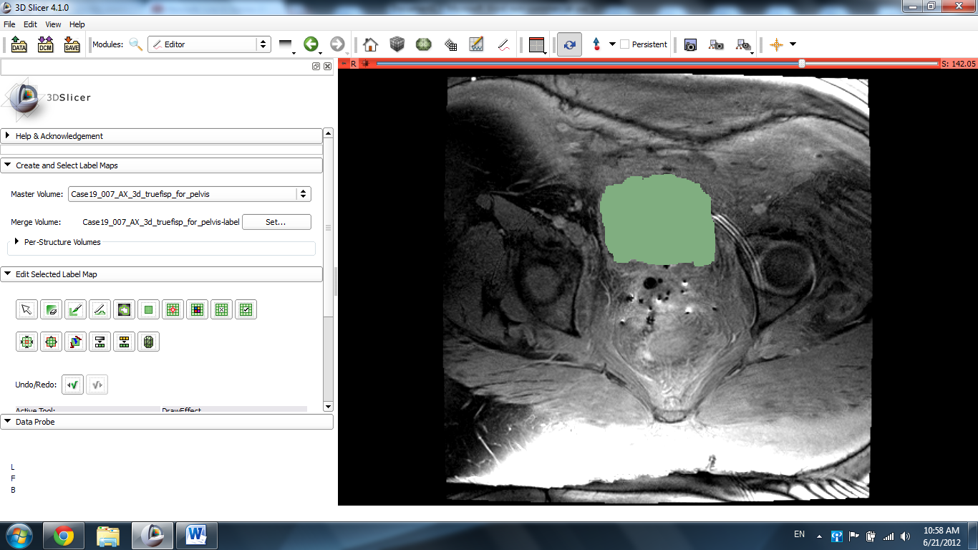

Note: The color of the label can be changed before the image is drawn using the Label tool in the sidebar.
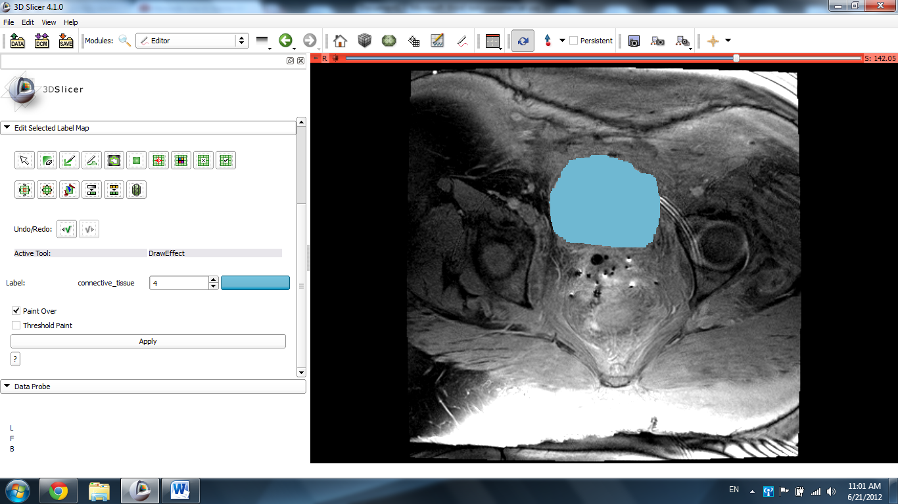

Repeat these steps for each slide individually as needed until each image of the bladder is labeled.
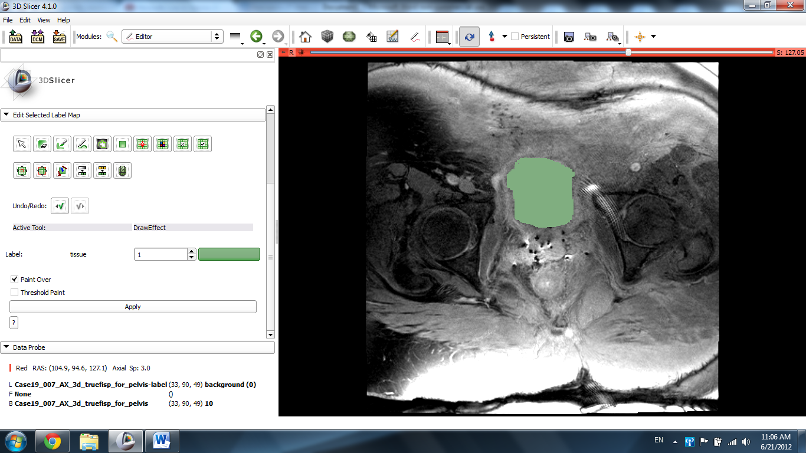

Once this is completed, click the pin icon in te top left corner of the window, followed by the double arrow icon.
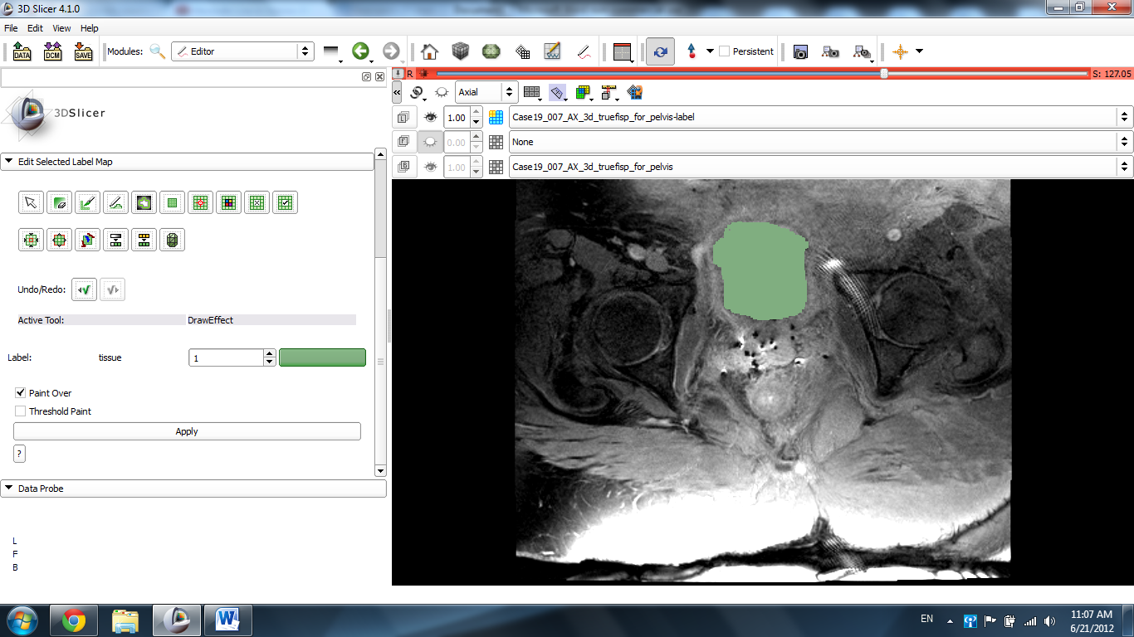

Hover the mouse over the window with the number 1.00 inside it next to the eye icon. Use the slider that appears to adjust the number to ~0.50. The labeled image fades slightly to reveal the labeled organ.
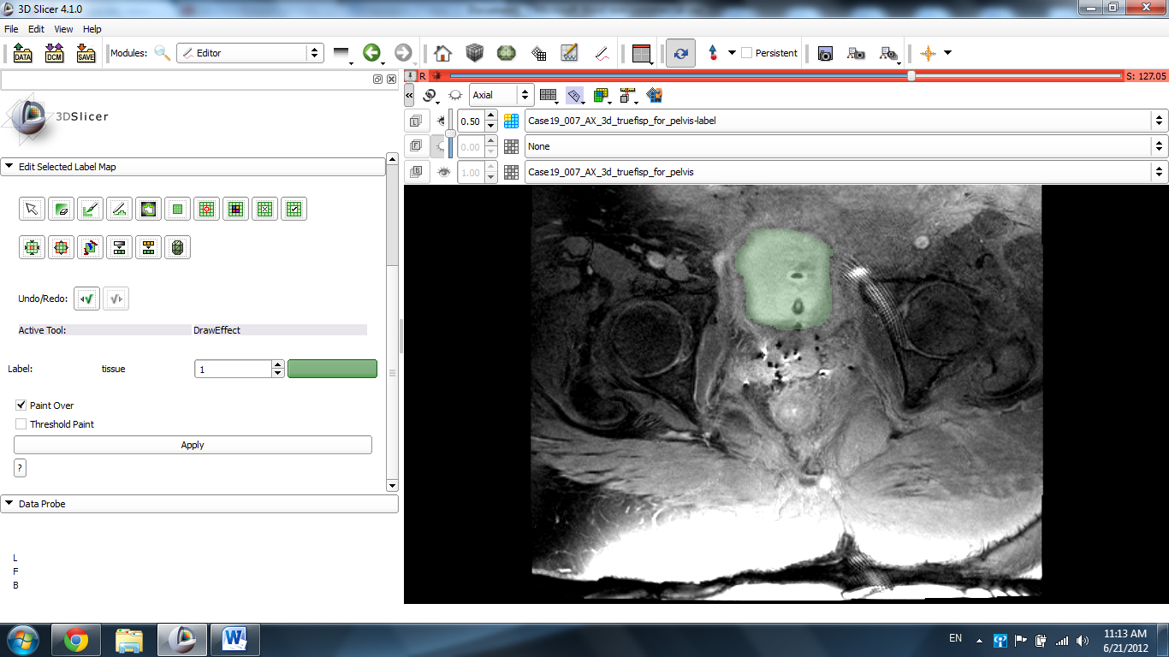

Click on the link icon to extrapolate this effect to he rest of the slides.
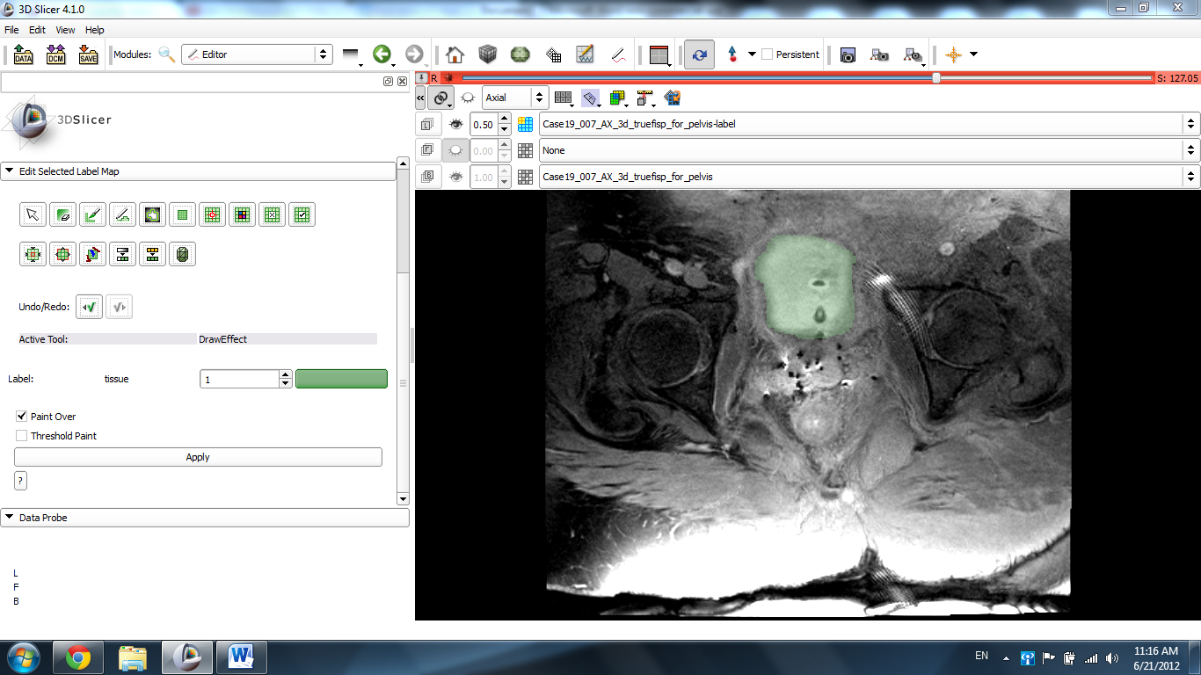
Scrolling through the slides will reveal that the structure in question has now been completely labeled.
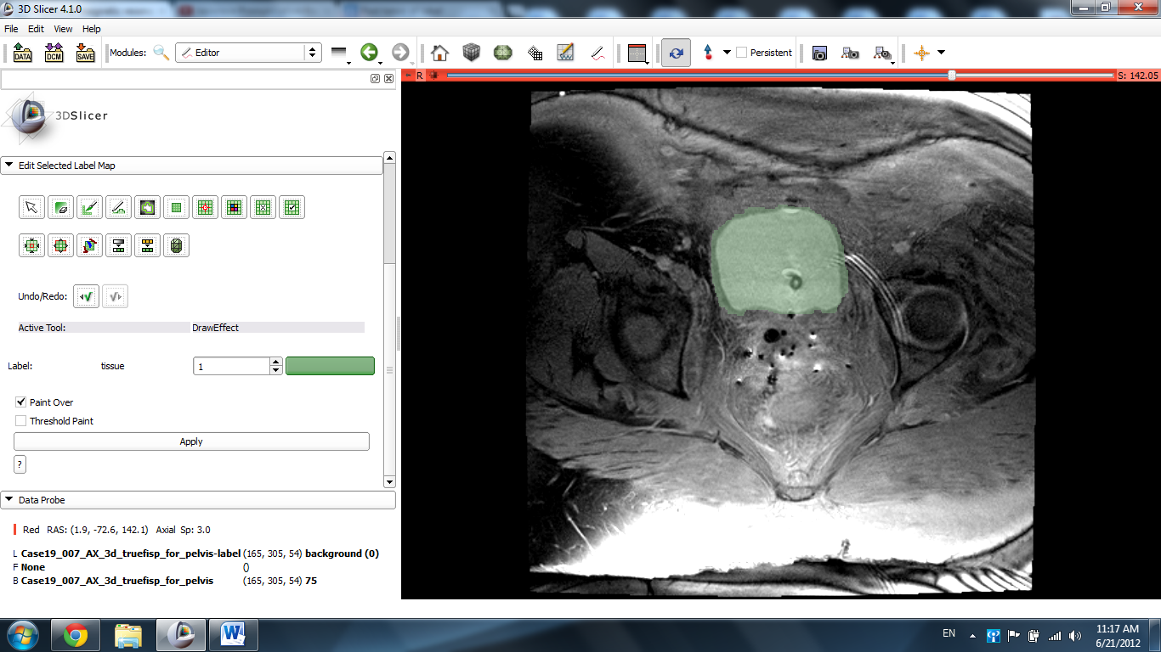

Click the Per Structures Volume Tab and then click Split Merge Volume.
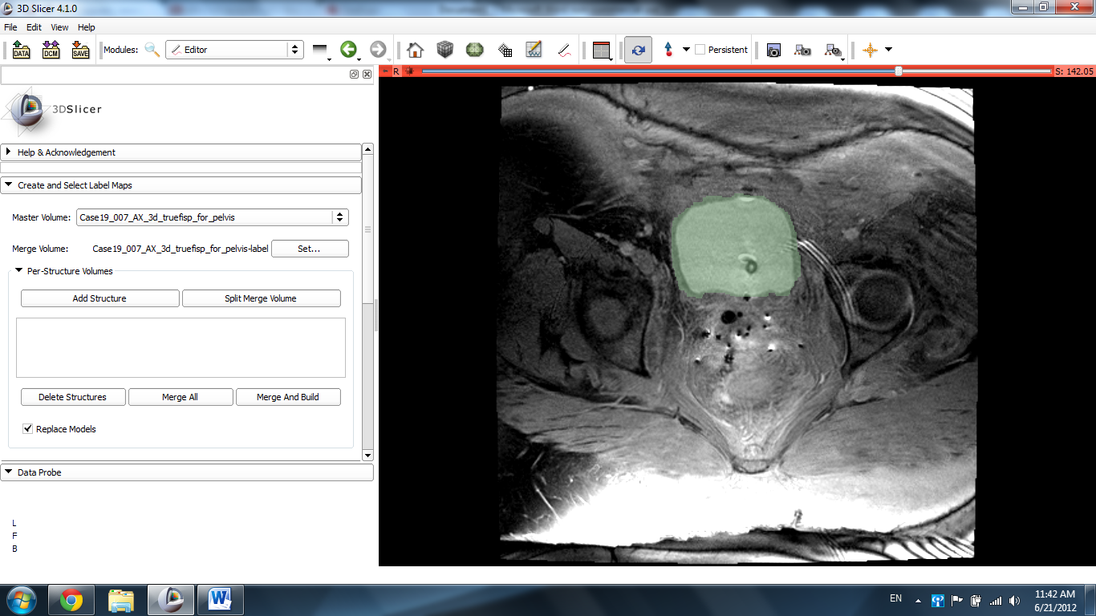

Click the label that corresponds to the label that you used and clck Merge and Build.
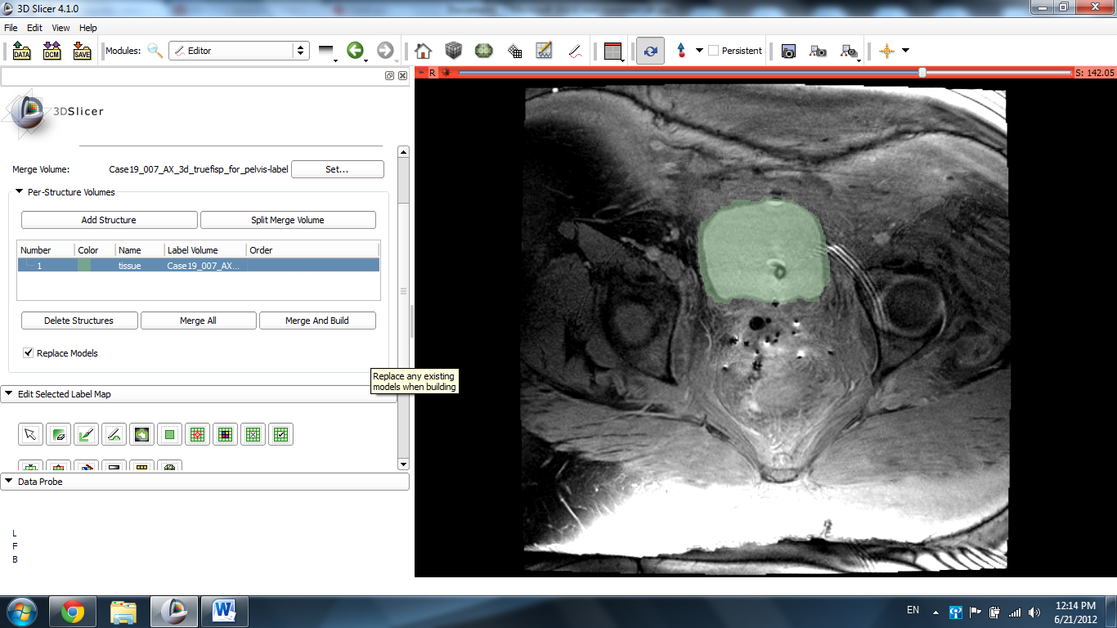

Switch the view back to the Conventional view.
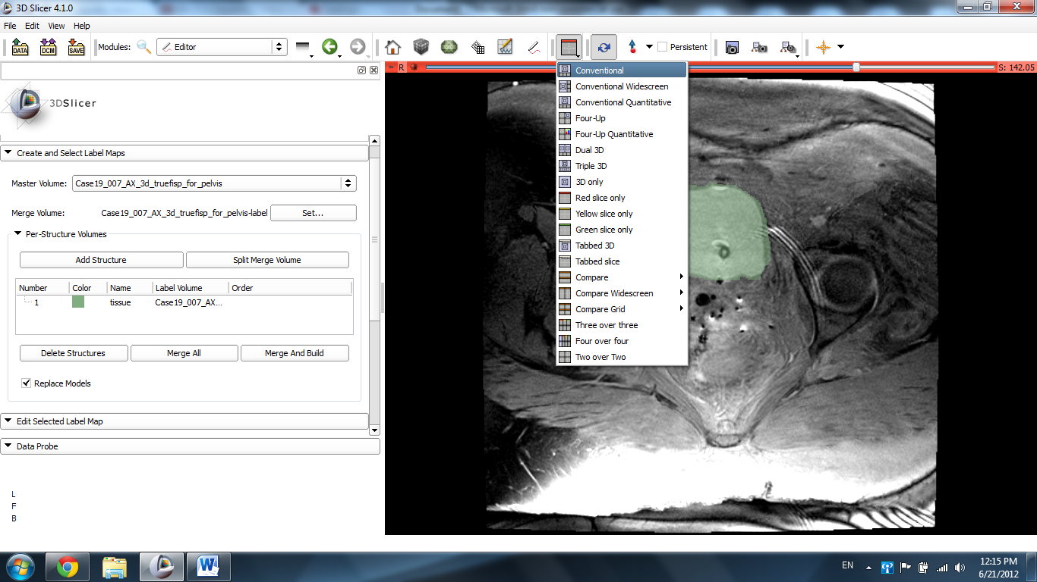

The segmented bladder image appears in the 3D Viewer, but off center.
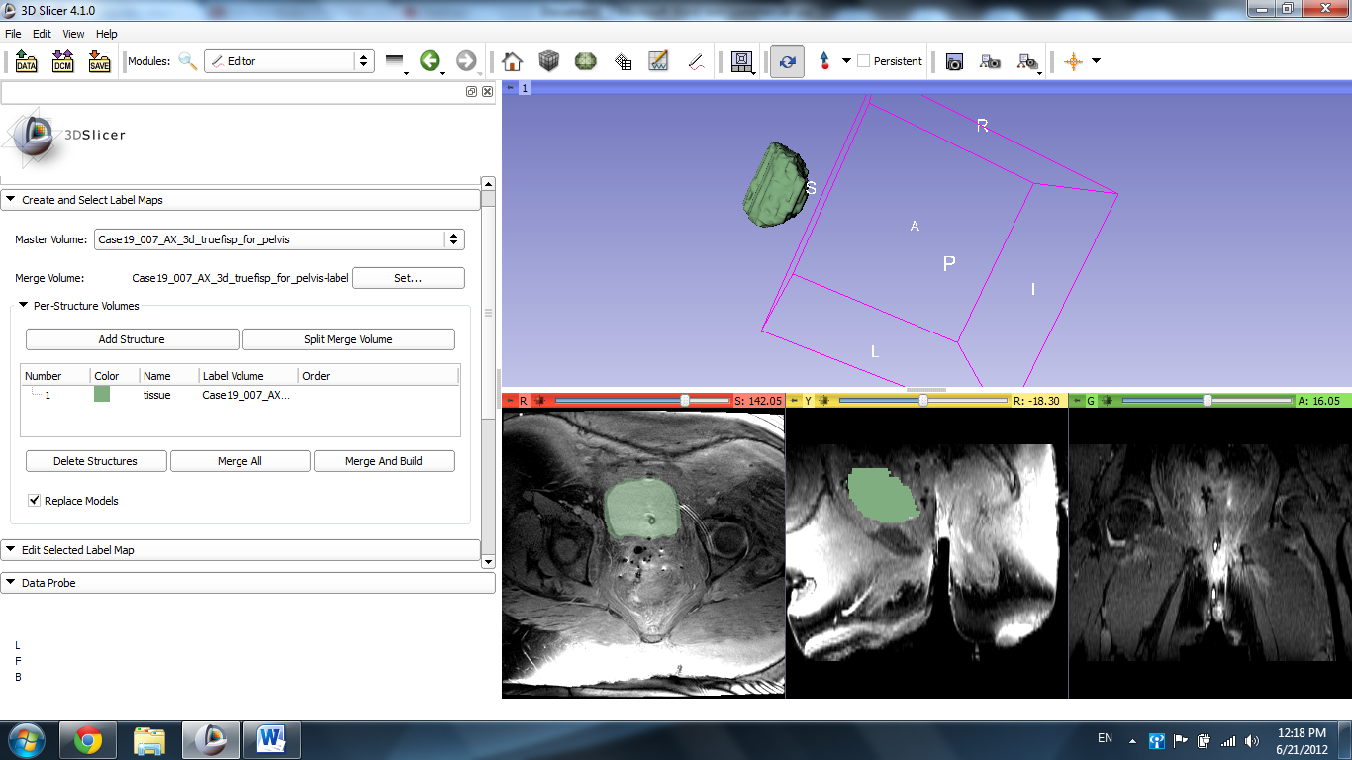

Click the pin in the top left of the screen and click the 3D center icon. The image centers on the screen.
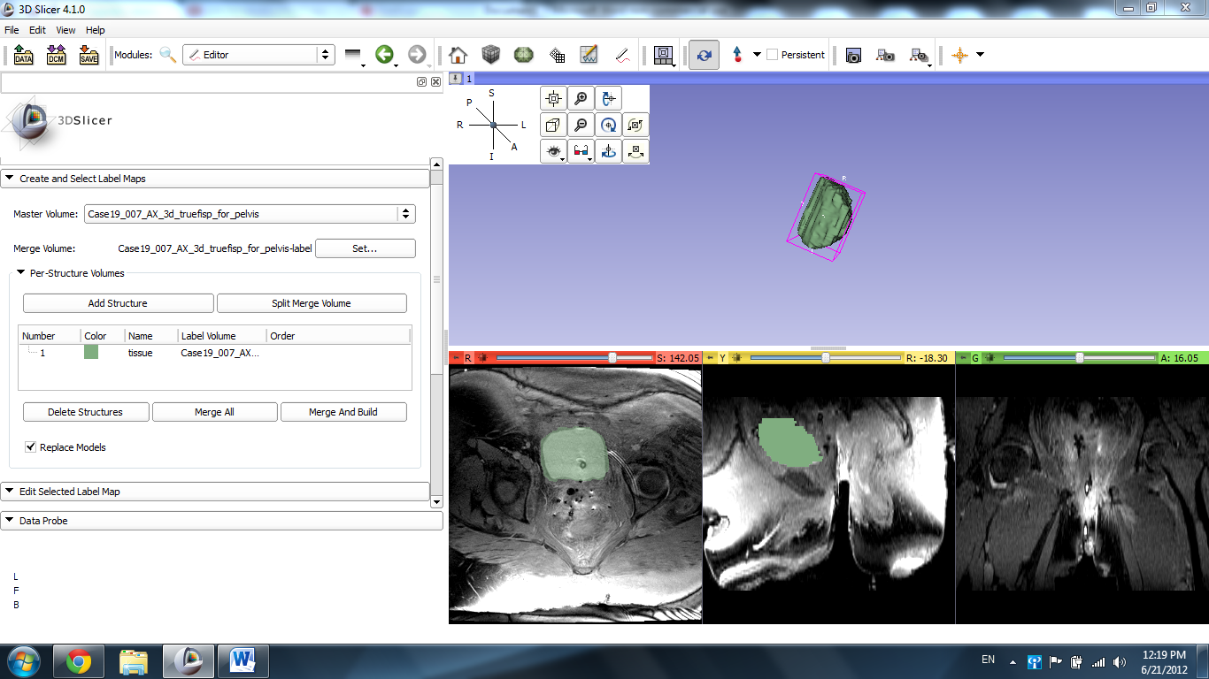

Finally, click the yellow slice top left pin, set the reader to ~0.50, and click the eye icon to display the slides in the 3D viewer to scale in relation to the model.
